
CORES™ RMS
Responder Guide
Version 4.33
© 2017 Collaborative Fusion, Inc., a subsidiary of Intermedix Corporation. All rights reserved.
This document contains confidential or proprietary information of Intermedix Corporation, and distribution should be limited to authorized persons only. Be aware that any disclosure, copying, distribution, or unauthorized and/or commercial use is strictly prohibited. While every precaution has been taken in the preparation of this document, Intermedix Corporation assumes no responsibility for errors or omissions. Neither is any liability assumed for damages resulting from the use of the information contained herein.

Intermedix™, the Intermedix logo, and Common Account Management® are registered trademarks of Intermedix Corporation.
All other trademarks are the property of their respective companies.

Address any questions, comments, or suggestions to:
support@intermedix.com
888-735-9559
424 Church Street, Suite 2400
Nashville, TN 37219
www.intermedix.com
Table of Contents
Responder Home 1
Profile 3
Summary 3
Identity 4
Deployment Preferences 5
Contact 6
Occupations 7
Training* 8
Skills and Certifications 9
Medical History 10
Background Check* 10
Settings 11
System Roles 12
Missions 14
My Availability 14
My Schedule* 15
Messages 16
General Messages 16
Check Messages 16
Compose a Message 18
Compose a Message: View 18
Add Recipients By Search 19
Manage Sent Messages 20
Share a Sent Message 22
Review a Sent Message 22
Use the Recipient Display Filter 26
Export a Sent Message 30
Document Library 33
Manage Draft Messages 34
Manage Trash Messages 35
More Information 36
Recipient Containers 36
Delivery Methods 37
Message Formatting 38
Voice Message Text-to-Speech Guidelines 45
Organizations 53
My Organizations 53
View My Organizations 53
Withdraw from an Organization 55
All Organizations 55
Edit Organization Details* 56
Manage Organization Members 58
Create an Access Level* 62
Manage Access Levels* 63
Add Members to Access Levels 65
Manage Network* 67
View and Message Organization Administrators 68
Join an Organization 69
View Reports* 69
Organizations Overview 70
Organization Administrators 71
Joining an Organization 71
Organization Membership Status 72
Access Levels 73
Network 74
Documents 75
Document Library 75
Manage Documents* 76
Create a Folder* 77
Manage Folder Details* 79
Add a File* 80
Manage File Details* 82
Check Files In and Out* 85
Manage File Versions* 86
Download a File 89
Manage Permissions* 89
Delete Folders and Files* 93
View Folder and File Logs 94
Move Folders and Files* 95
Create a Shortcut* 96
Watch Folders and Files 97
Permissions 97
State and System Administrator Permissions 97
General Permission Options 98
File Check-in and Check-out 99
File Shortcuts 99
My Documents 100
My Watched Documents 101
Document Search 102
Accountability 104
Time & Attendance 104
Check Responders In and Out 105
View Time and Attendance Log 106
Change Deployment Status 107
Assign Responders to Jobs* 109
Scanning Responder Badges* 110
Deployment Status 111
My Status 113
Change Your Deployment Status* 113
Check In and Out 114
Glossary 115
Index 121

Responder Home
After you log into the system, the Home page appears. Your Home page shows your most recent updates and messages.
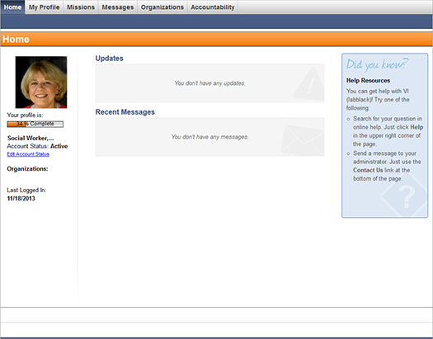
Important: Your system is designed to run in a single browser tab. Be aware that problems can occur if you try to run RMS in multiple tabs.
The Home page has the following sections:
- Profile - This section displays a percentage bar that indicates how much information you have completed within your profile. It also displays whether your account is active or inactive and the organizations you manage or belong to. Click Edit Account Status to make changes to your account.
Note: In order for you to be eligible for potential deployments, all required profile information must be complete. Please take some time to fill out each required and optional section in your profile.
- Announcements - This section displays announcements posted by the System Administrator. Click the name of an announcement to view its details. This section does not appear if no announcements are available.
- Updates - This section notifies you about the most recent activity in the system, such as missions, deployments, and availability requests.
- Recent Messages - This section shows the last ten messages that you received in your mailbox. Click the name of a message to open it in your Inbox. The number in parenthesis shows the number of unread messages you have in your Inbox. You can check your Inbox at any time by going to the Messages tab.
- Did you know? - This section provides an overview of the help center and contact information for Intermedix® Support.

Profile
You can quickly and easily access and manage your profile from the My Profile tab.
For more information and step-by-step procedures, refer to the following:
● Summary
● Identity
● Deployment Preferences
● Contact
● Occupations
● Training
● Skills and Certifications
● Medical History
● Background Check
● Settings

Summary
The Profile Summary page displays responder information completed during the initial registration. A summary indicator shows the percentage of the responder profile that is complete. In order for a responder to be eligible for potential deployments, all required profile information must be complete.
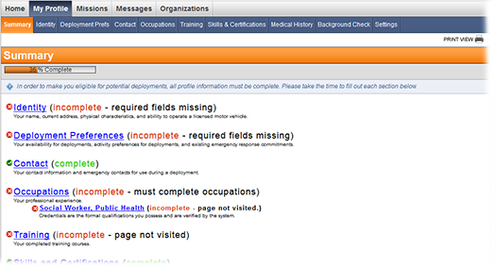
Tip: To edit profile information, click the blue link for the section to modify or click the appropriate link in the secondary navigation bar.
The History of Changes section at the bottom of each page in the Profile section displays any changes made to that section.
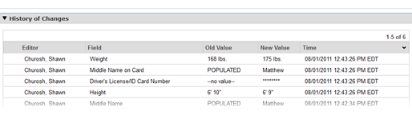

Identity
To access the Identity page, go to My Profile: Identity. The following page opens.
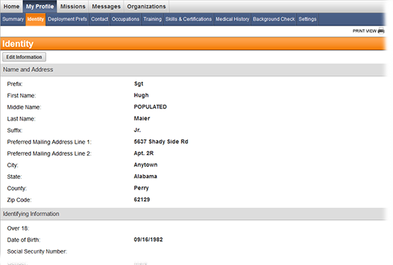
In addition to the information collected during the initial registration, you can use this page to enter an alternate address and identifying information such as date of birth, gender, and height. You can also update your driver license information, other state license information, and any license endorsements. All information entered during the initial registration is saved and automatically appears on the page.
Tip: To edit your identity information, click the Edit Information button on the top left of the page. Click Save Changes when you are finished.

Deployment Preferences
To access the Deployment Preferences page, go to My Profile: Deployment Prefs. The following page opens.
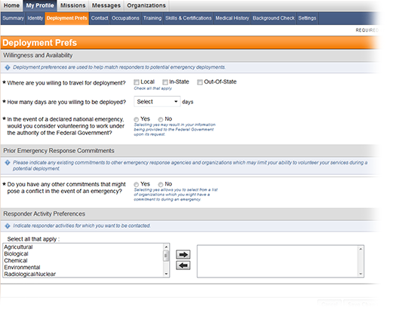
In Deployment Preferences, you can indicate your willingness and availability for deployments, prior emergency response commitments, and any activity preferences if they are enabled on your system.
Tip: To edit your deployment preferences, click the Edit Information button on the top left of the page. Click Save Changes when you are finished.

Contact
To access the Contact page, go to My Profile: Contact. The following page opens.
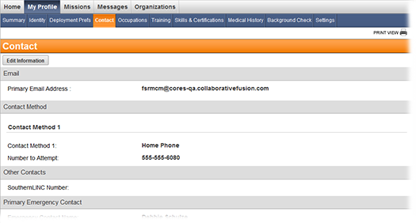
Click Edit Information to perform the following tasks:
- Provide a primary email address. Without an email address, important messages and notifications may be missed. The system does not allow two accounts with the same email address.
- Enter at least one contact method. Enter additional contact methods to make sure your coordinator can reach you during emergency situations. Use the X button to delete a contact method.
- Use the arrows to reorder contact methods in the desired priority level. You will receive notifications in the order the contact methods are listed.
- Specify a primary emergency contact who should be notified in the event of a personal emergency during deployment.

Occupations
To access the Occupations page, go to My Profile: Occupations. The following page opens.
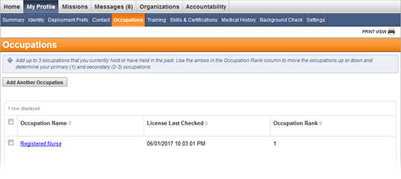
To add an occupation
1. Go to My Profile: Occupations.
2. Click the Add Another Occupation button.
3. Enter the appropriate occupation information. Required fields are marked with an asterisk (*).
Field | Description
What is your occupation type? | Select whether the occupation type is medical or non-medical.
Occupation | Select the specific occupation from the drop-down list. Select Other if your occupation does not appear in the list.
What is your current professional status for this occupation? | Select your professional status for the selected occupation.
4. Click Save Changes.
Each registered responder must have no less than one and no more than three occupations listed. You can include professions you are not actively practicing but have a license or professional certification for.
Tip: You can edit an occupation by clicking its name. To delete an occupation, select an occupation from the list and click the Delete button. If you have only one occupation listed, the system will not allow you to delete it. In this situation, add the new one first, then delete the old occupation.

Training*
* Note that you may not have access to this feature depending on your system configuration.
To access the Training page, go to My Profile: Training. The following page opens.
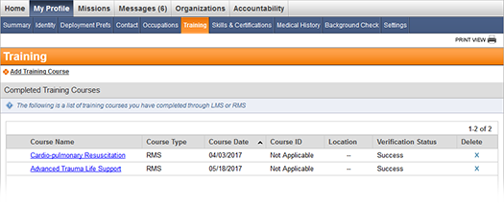
You can use this page to enter information on training courses you have completed and upload training certificates. Once training courses are added to your record, an administrator can verify credentials to ensure the information is accurate.
To add a training course
1. Go to My Profile: Training.
2. Click the Add Training Course link.
3. Enter the training course information. Required fields are marked with an asterisk (*).
Field | Description
Training Course | Select the training course from the drop-down list.
Institution | Enter the name of the institution where the training was completed.
Training Course Date | Enter the date you completed the training course.
Expiration Date | Enter the date your training expires. Select the check box if the course has no expiration date.
Upload Certificate | Click the Browse button to add a training certificate. Click Add Another Certificate to add multiple certificates.
Verification Status | Set a verification status if a credential check has been performed on your profile.
Verification Notes | Enter any notes regarding the verification status.
4. Click Save Changes.
To perform other actions:
● Click the name of a training course to open it for editing.
● To delete a training course, select it from the list and then click Delete Training Courses.
● Optionally click the name of a training course in the Training Sessions section of the page to sign up for an upcoming training course.

Skills and Certifications
To access the Skills & Certifications page, go to My Profile: Skills & Certifications. The following page opens.
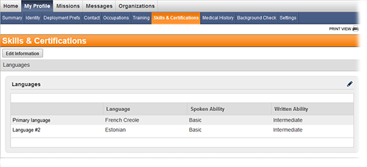
Use this page to enter your skills and certifications obtained either through a certification process or through non-required training. You can also enter languages you speak and your prior deployment experience. These elements are used to determine potential eligibility for deployments.
Tip: To edit your skills and certifications, click the Edit Information button on the top left of the page. Click Save Changes when you are finished.

Medical History
To access the Medical History page, go to My Profile: Medical History. The following page opens.
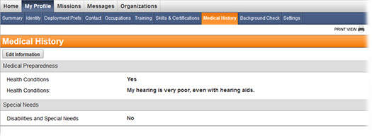
Use this page to verify and update your medical history. This information is collected to ensure a your safety during a deployment.
Tip: To edit your medical history, click the Edit Information button on the top left of the page. Click Save Changes when you are finished.

Background Check*
* Note: This section may be used differently, or not used at all, by your system administrators. You also may not be able to view your status in the way shown.
To view the status of your background check, go to My Profile: Background Check. The following page opens.
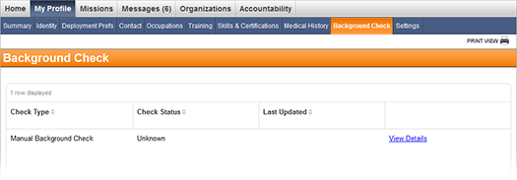
Click the View Details button for an explanation of your status.
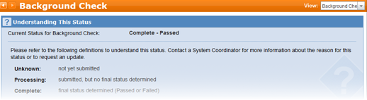
If you have not completed a form required for any of the checks, the Complete Form button appears in the column on the right. Click this button to open the form.
After you complete the form, you can submit it electronically or print it. Check with your administrator on the preferred way of submitting the form.

Settings
To access settings for your account, go to My Profile: Settings. The following page opens.
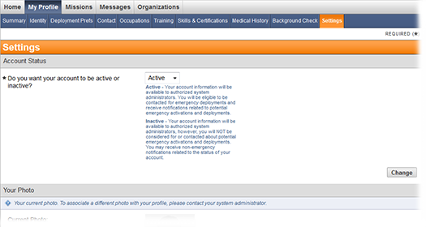

To edit settings
1. Go to My Profile: Settings.
2. Select or enter the information in the desired category. Required categories are marked with an asterisk (*).
Field | Description
Account Status | Select whether your account should be active or inactive. Inactive accounts are not considered for potential emergency deployments. Consider making your account inactive if you will be unavailable for an extended period of time.
Your Photo | You can upload a new photo by clicking Browse, selecting the desired photo, and then clicking Upload. If your computer has a webcam, you can click Toggle Webcam View to take a photo.
System Role | Displays your current system role. Only system administrators have the ability to change your system role.
Username | Displays your current username. To change your current username, enter a new username in the New Username field.
Password | If you would like to change your password, enter your current password, then enter and confirm your new password. Follow the guidelines in the box on the right when choosing a new password.  If you are an administrator wanting to change a responder's password, open a responder's profile window and click the Settings tab.
Secret Question and Answer | Select a secret question from the drop-down list and enter your answer to the question. You are prompted to answer this question if you forget your password.
Display Preferences | Select how many table results you would like to view by default on pages with tables or result sets.
3. Click the Change button in the lower right corner of the section.

System Roles
System role types include:
● Responder - Responders with this role have limited system-wide access. Responders do not have the ability to manage or view others in the system, and they can only compose messages to administrators and respond to notifications they receive. They do not have access to the Administration or Configuration modules. Their access can be limited or expanded by their assigned organization access level permissions and other granular permissions in the Organizations, Document Library, and Accountability modules, where available.
● Local Administrator/Regional Administrators - Responders with this role can perform many functions in the system, including some access to the Administration and Configuration modules. These administrators are limited by organization access level permissions in the Messages, Organizations, Document Library, Accountability, and Mission Manager modules, where available.
● System Coordinator - Responders with this role can perform all functions available on the system and have full access to the Administration and Configuration modules. They have access to all organizations and can modify details, members, access levels, unaffiliated responders, and network information for any created organization, regardless of their access level permissions. They can also manage users within the system.
● Call Center Operator (Optional) - Responders with this role can view all missions and send notifications. Not all systems contain this system role.

Missions
Missions are potential deployment situations, such as emergencies and preplanned events. Mission Manager allows you to manage missions, deployments, requests, and responders from pre-deployment through demobilization.
For more information and step-by-step procedures, refer to the following:
● My Availability
● My Schedule

My Availability
The My Availability page lists each deployment group for which you are qualified. You may see a deployment group listed multiple times if you are qualified for more than one position.
To access the My Availability page, go to Missions: My Availability.
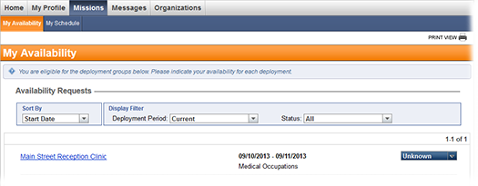
Indicate your availability for the deployment period using the drop-down menu in the row of the deployment. Selecting Available indicates to the Administrator that you are willing and able to work during the specified deployment period.
If an administrator assigns you to this deployment group, you receive a notification and your status is updated to Assigned on this page. Click a deployment group's name to view additional information that the administrator has provided, including:
● Mission information
● Work description
● Check-in and service locations
● Contact information
● Accommodations
● Items to bring
● Deployment instructions

My Schedule*
* Note: This function might not be available to you due to the configuration of your system.
When an administrator assigns you to a shift, it appears on this page as your final schedule. To access the My Schedule page, go to Missions: My Schedule.
You will receive a notification each time your schedule changes. Click a deployment group's name to view additional information that the administrator has provided, including:
● Mission Information
● Work description
● Check-in and service locations
● Contact information
● Accommodations
● Items to bring
● Deployment instructions

Messages

General Messages

Check Messages
The messages that you receive from other people are stored in your Inbox with information about the type of message, subject, sender, and date. When you have unread messages, a number appears in the Messages tab to let you know. By default, messages are listed in chronological order with the most recent message at the top.
Note: The images in this procedure show the system as it appears by default, and the tabs, fields, and labels on your page may be different.
To organize messages in your Inbox, you can sort messages by column headers, mark messages as read or unread, or delete messages.
To check for new messages
1. Go to Messages, and if it is not already selected, then on the left, click Inbox. Your Inbox opens.
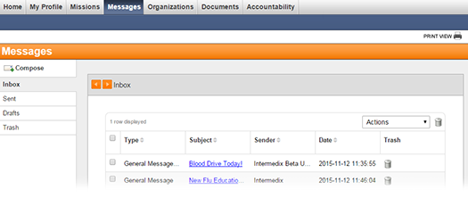
2. Optionally, take any of these actions.
If you want to... | Then...
Sort messages, | ● Click a column header (for example, Type, Subject, Sender, or Date). The messages are rearranged in alphabetical or ascending order depending on the contents.  ● Click the column header again to rearrange messages in the reverse alphabetical or descending order.
Mark messages as read or unread, | ● On the row for each message that you want to mark, select the check box.  ● Then, in the Actions menu, click Mark as Read or Mark as Unread.
Send messages to the Trash, | ● To send one message to the Trash, on that message row, click the delete icon .  ● To send multiple messages to the Trash, on each message row, select the check box. Then, on the upper, right of the table, click the trash icon .
3. To open a message, click the message subject. The message page opens.
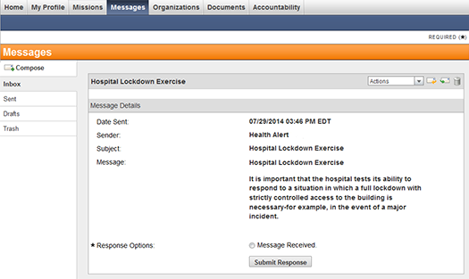

Compose a Message
The messages that you compose are used to notify people about events and provide information. If applicable, messages can then be used to track message delivery and user responses. There are many options that define when, how, and what information is sent in your message.
Note: The images in this procedure show the system as it appears by default, and the tabs, fields, and labels on your page may be different.

Compose a Message: View
System users who do not have administrative rights have different messaging options. The following instructions are intended for the system users without administrative rights.
To compose a message
1. Go to the Messages tab and select the Compose side tab on the left. The following page opens.
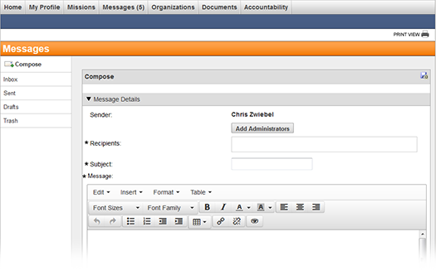
2. Complete the appropriate fields. Required fields are marked with an asterisk (*).
Field | Description
Sender | Displays your name.
Recipients | Add administrators that you want to receive your message.  Note: Administrators that you have permission to message appear in the list.
Subject | Enter the message subject.
Message | Enter the message text. You have a number of formatting options available to you when constructing the Message content. Options include choosing font details such as family and size, formatting such as bold, italic, and underline, paragraph alignment and indentation, and list creation. You can also add a table and create hyperlinks. You can even view and work with your message's source code. Refer to Message Formatting for more information.
3. Optionally, to save the message as a draft, click the save draft icon .
4. When you are ready, click Send.

Add Recipients By Search
When you are composing a message , you can search for recipients, select the Administrators, and then add them to your message.
To add recipients
1. On the Compose page, click Add Administrators and the Search Center window opens.
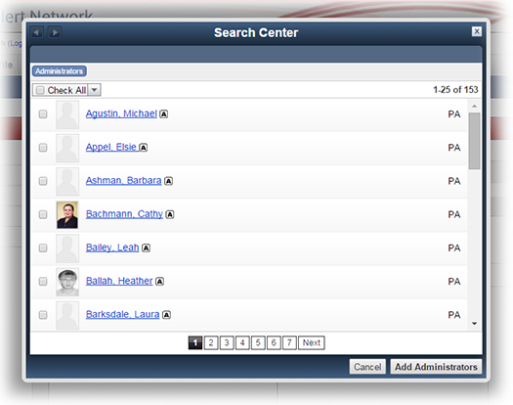
If you want to... | Then...
Search for an individual, group, or organization by name, | ● In the Search field, type the name or the first few letters of the name.  ● Click Search. The search results appear.  ● Select the check box for those that you want to receive the message, and click Add. Your selections are added to the All Recipients field.
View all Individuals, Administrators, Groups, or Roles, and select a few, | ● Click Individuals, Administrators, Groups, or Roles.  ● Click Search. The search results appear.  ● Select the check box for those that you want to receive the message, and click Add. Your selections are added to the All Recipients field.
View all Organizations, and the users, departments, and/or subdivisions contained within an organization's hierarchy, and select a few, | ● Click Organizations. The Organization Selection window opens.  ● Select the check box for those that you want to receive the message, and click Add. Your selections are added to the All Recipients field.
2. Select the check box for all administrators that you want to receive the message, and click Add. Your selections are added to the Recipients field.

Manage Sent Messages
The messages that you send to other people are stored in the Sent messages folder. Sent messages are maintained so that you can review, update, cancel, or export the messages. Each sent message contains detailed information about message delivery statuses and recipient responses, which allows you to better manage the notification and analyze delivery options for future messages.
Note: This procedure may not be available due to your system configuration. The images in this procedure show the system as it appears by default, and the tabs, fields, and labels on your page may be different.
By default, the Sent messages folder only lists messages sent by you and they are listed in chronological order with the most recent message at the top.

To manage sent messages
1. Go to Messages, and on the left, click Sent. The Sent messages page opens.
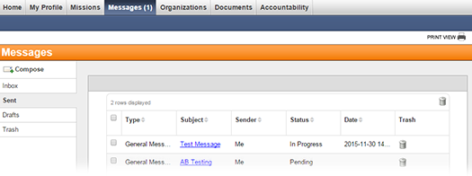
2. Take any of these actions.
If you want to... | Then...
Sort messages, | ● Click a column header (for example, Type, Subject, Sender, Status, or Date). The messages are rearranged in alphabetical or ascending order depending on the contents.  ● Click the column header again to rearrange messages in the reverse alphabetical or descending order.
View the details of a message, | ● Click the linked Subject. The message opens.  ● Continue with the procedure to Review the Message and Message Statistics, Use the Recipient Display Filter, and/or Export a Sent Message.
Filter messages,
Send messages to the Trash, | ● To send one message to the Trash, on that message row, click the delete icon .  ● To send multiple messages to the Trash, on each message row, select the check box. Then, on the upper, right of the table, click the trash icon .  Note: You can only delete messages that you sent, unless you are a system coordinator. If you are a system coordinator, then you can delete any message. Deleting messages removes them from the system, but system coordinators can retrieve deleted templates from the database if necessary.

Share a Sent Message
As an administrator, you can share sent messages with other administrators. Even if another administrator was included as a message recipient, they cannot see the sent message statistics unless you share the sent message with them. When you share the message, it will show in that administrator's Sent messages list; they can easily locate it by choosing the Shared with Me option in the Display Filter.
To share a sent message
1. Go to Messages, and on the left, click Sent.
2. Locate the message or messages, and select each message's check box.
3. Open the Select an action drop-down list and click Share Message.
4. Click Submit Action. The Search Center window opens.
5. Enter all or part of the administrator's name and click Search.
6. Select one or more administrators from the list of results.
7. Click Share Message.

Review a Sent Message
Sent messages preserve details about the message composition, and act as a repository for recipient response data. Sent messages can be reviewed, exported, or deleted.
There are two main sections of a sent message, including the Message Summary and Message Details. The Message Summary provides a quick overview of the message with the Total Recipient count, and the Message Details section provides mostly static information about the message and the parameters of how it was composed.
Click data in a sent message to open the Recipients Display Filter, which allows you to view, filter, or export recipients based on Recipient Container, Delivery Status, or Response Time.
Note: The images in this procedure show the system as it appears by default; the tabs, fields, and labels on your page may be different.
To review a sent message
1. Go to Messages, and on the left, click Sent. The Sent messages page opens.
2. Locate the message that you want to review, and click the subject. The message opens.
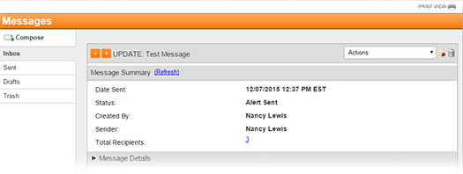
3. To expand or contract message sections, click the arrow on the left of a section header.
4. If you want to review information about message recipients, then go to the Message Summary or Message Details section, and click the linked number of Total Recipients. The Recipients Display Filter opens with the Basic filter set to display all recipients.
If you want to review information about... | Go to the... | And...
All recipients, | Message Summary or Message Details section, | Click the linked number of Total Recipients. The Recipients Display Filter opens with the Basic filter set to display all recipients.
Recipients with a particular delivery status, | Message Summary section, and in the Delivery Status table, | Click a linked Status. The Recipients Display Filter opens with the Basic filter set to display recipients with that status.
Recipients with a particular response, | Message Summary section, and in the Response Options table, | Click a linked Response. The Recipients Display Filter opens with the Basic filter set to display recipients with that response.
Recipients that responded in a certain time frame, | Recipient Statistics: All Recipients section, and in the Responses Over Time table, | Click a linked time frame. The Recipients Display Filter opens with the Basic filter set to display recipients that responded in that time frame.
Recipients that received the message through a certain method, | Recipient Statistics: All Recipients section, and in the Responses By Delivery Method table, | Click a linked Delivery Method. The Recipients Display Filter opens with the Advanced filter set to display recipients who received the message through a certain method.
Recipient containers, | Recipient Statistics: By Containers section, and in the Recipient Containers table, | Click a linked:  ● Container to open the Recipients List and view the total number of recipients, Delivery Status, Response Options, Responses Over Time, and Responses By Delivery Method data. Click linked information on the Recipients List to open the Recipients Display Filter with the filter set to display data about recipients in that container.  ● Recipient Count to open the Recipients Display Filter with the Basic filter set to display all recipients in that container.  ● Responded to open the Recipients Display Filter with the Basic filter set to display recipients in that container who responded.  ● No Response to open the Recipients Display Filter with the Basic filter set to display all recipients in that container who did not respond.  ● View Values in the Failed column to open the Recipients Display Filter with the Basic filter set to display all recipients in that container for whom delivery failed.  ● Not Contacted to open the Recipients Display Filter with the Basic filter set to display all recipients in that container who were not contacted.
Message delivery specifications, | Advanced Delivery Options section, | Review the message delivery information.
Message basics, | Message Details section, | Review basic information about the message, such as the Sender, Total Recipient count, Subject, Message Types, and Message Format.
5. Optionally, take any of these actions:
If you want to... | Then...
Send a message update, | ● On the Actions menu, click Update Communication. The Compose page opens.  ● Enter updates, and then send the message.
Send a message cancellation, | ● On the Actions menu, click Cancel Communication. The Compose page opens.  ● Enter corrections, and then send the message.
Save the message as a template, | On the Actions menu, click Save as Template or click the save as template icon .
Export the message, | On the Actions menu, click Export or Export to Document Library (if configured for use in your system).
Delete the message, | Click the trash icon .

Use the Recipient Display Filter
After you send a message, you can review the message, and then access the Recipients page to use the Recipient Display Filter.
When the Recipients page opens, the filter fields on the Recipients Display Filter correspond to the linked data that you clicked to access the page. The results, or recipient data, corresponds to the selected filter fields and shows the recipients' names, the date and time of the last contact attempt, the total number of contact attempts, and the response. When you change filter field selections, the resulting recipient data is adjusted to provide valid results.
Note: The images in this procedure show the system as it appears by default, and the tabs, fields, and labels on your page may be different.
For more information, go to the topic Recipient Display Filter.
To view message recipients
1. Go to Messages, and on the left, click Sent. The Sent message folder opens.
2. Locate the message, and click the message subject. The message opens.
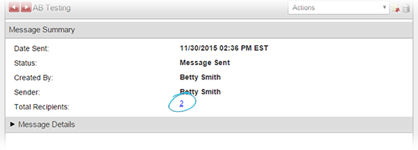

3. To review the recipient information, click the linked number of Total Recipients.
If you want to review information about... | Go to the... | And...
All recipients, | Message Summary, Recipient Statistics: All Recipients, or Message Details section, | Click any linked number, status, or response parameter. The Recipients page opens.
Recipients in a specific container, | Recipient Statistics: By Containers section, | Take one of these actions:  ● Click any linked number, and the Recipients page opens.  ● Click a linked Recipient Container, and the Recipient List opens. Click any linked number, status, or response parameter. The Recipients page opens.
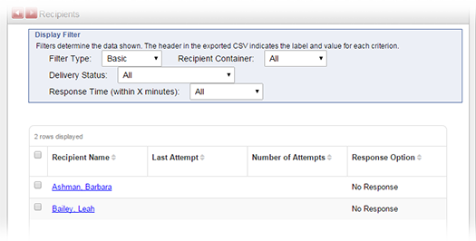
4. Review the recipient data.
5. To use the Display Filter:
If you want to... | Go to the filter menu... | And...
View information about the device on which the recipient received the message, | Filter Type, | Click Advanced. A column with recipient Device information appears.
View information for a specific container of recipients, | Recipient Container, | Click the name of a container. The table refreshes to show only recipients in that container, who also have the selected Delivery Status and Response Time.
View information for recipients with a specific combination of the Delivery Status and Response Options, | Delivery Status, | Click a Delivery Status. The table refreshes to show only recipients with that status, who also have the selected Recipient Container and Response Time.
View information for recipients with a specific response time, | Response Time, | Click a Response Time. The table refreshes to show only recipients with that time, who also have the selected Recipient Container and Delivery Status.
View information for recipients who had the message delivered with a specific method, | Filter Type, and then Response Time, | For Filter Type, click Advanced. The table refreshes.  For Delivery Method, click a Delivery Method. The table refreshes to show recipients who received the message with that Delivery Method.
6. Optionally, take any of these actions:
If you want to... | Then...
Sort messages, | ● Click a column header (for example, Type, Subject, Sender, Status, or Date). The messages are rearranged in alphabetical or ascending order depending on the contents.  ● Click the column header again to rearrange messages in the reverse alphabetical or descending order.
Export delivery and response data for all resulting recipients, | Click the Export Filter Results (CSV) icon, and the file is downloaded through your browser.
View a recipient's profile, | Click the linked Recipient Name. The person's Profile opens in a new window. The Profile contains contact, group, organization, employment, change history, and account settings for that person.
Send a message to a recipient, | ● On the row for each recipient that you want to message, select the check box.  ● In the Select an action menu, click Send Message.  ● Click Submit Action. The Compose message page opens, and the selected recipients are already added as recipients on the new message.
Add one or more recipients to an existing group, | ● On the row for each recipient that you want to message, select the check box.  ● In the Select an action menu, click Add to Existing Group. The Group Name menu appears.  ● Click Submit Action. The recipients are added to the group and the table refreshes to deselect them.
Add one or more recipients to a new group, | ● On the row for each recipient that you want to message, select the check box.  ● In the Select an action menu, click Add to New Group. The Group Name, Viewable By and Allow other administrators to make changes or delete this group fields appear.  ● Enter the information.  ● Click Submit Action. The recipients are added to the group and the table refreshes to deselect them.
Export delivery and response data for a select group of resulting recipients, | ● On the row for each recipient that you want to message, select the check box.  ● In the Select an action menu, click Export Users.  ● Click Submit Action. The Compose message page opens, and the selected recipients are already added as recipients on the new message.

Export a Sent Message
Sent messages can be exported for review and reporting in portable document format (PDF) and/or comma-separated value (CSV) files, and there are three ways to define and delimit the information included in the export:
● A report including information about the Delivery & Recipient Statistics, Message Details, and/or Recipients can be exported from the sent message page, in a PDF or CSV file, and the file is downloaded through your internet browser to the default or selected destination folder. Files exported this way can be opened, viewed and edited using Adobe® Acrobat® for PDF files or a spreadsheet or text editor program for CSV files.
● If the Document Library is configured for your system, a report including information about the Delivery & Recipient Statistics, Message Details, and/or Recipients can be exported from the sent message page, in PDF and CSV files, and the files will be saved to the Document Library. Files exported this way can be accessed and managed from within the system, and they can be downloaded as well.
● Alternately, a partial report for a set of message recipients can be generated for export from the Recipients page. Partial reports can be exported for all recipients that result from an applied filter as a CSV file and the file is downloaded through your internet browser to the default or selected destination folder. Files exported this way can be opened, viewed and edited using a spreadsheet or text editor program.
Note: The images in this procedure show the system as it appears by default, and the tabs, fields, and labels on your page may be different.

To export from the sent message page
1. Go to Messages, and on the left, click Sent. The Sent message folder opens.
2. Locate the message, and click the message subject. The message opens.
3. Take one of these actions.
If you want to... | Then...
Export the message for direct download, | In the Actions menu, click Export. The Export Message window opens.  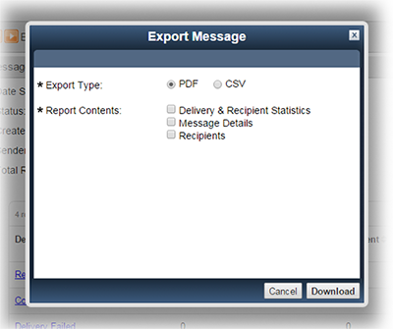
Export the message to the Document Library, | In the Actions menu, click Export to Document Library. The Export Message window opens.  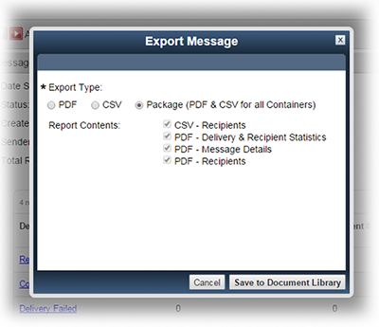  Note: The Export to Document Library and Package option are only available if your system is configured with the Document Library.
Export the message for direct download or to the Document Library, | Click the export icon . The Export Message window opens.
4. Select the Export Type and Report Contents, and click Download or Save to Document Library. Depending on the Export Type that you select, the message is downloaded through your browser or sent to the Document Library.
Note: For Export Type, if you select Package (PDF & CSV for all Containers), then all Report Contents options are selected and cannot be deselected.

To export from the Recipients page
1. Go to Messages, and on the left, click Sent. The Sent message folder opens.
2. Locate the message, and click the message subject. The message opens.
3. For any linked field (for example, Total Recipients), for which you want to generate the export, click the linked name or number. The Recipients page opens.
4. Use the Display Filter to generate the results that you want to export.
5. To export the current filter results, click Export Filter Results (CSV). The file is downloaded through your browser.
If you want to... | Then...
Export all filter results, | Click Export Filter Results (CSV). The file is downloaded through your browser.
Export a subset of filter results,

Document Library
Once the exported report is generated, you can click Go To Document Library to view the reports or click Close to continue working with your Sent messages.
In the Document Library, exported messages are saved in the Sent Messages folder as subfolders. Messages are identified with the export date, time, and the name of the message. If the message was sent to recipients in more than one container, then the message folder contains subfolders for each container.
The message summary, statistics and details are saved as a report at the message level, and if there are container folders, then the report for each container is saved within the respective container folder as well.
Standard permissions and access rules apply to folders and files in the Document Library. This means that reports created for a sent message is only accessible to the person who exported the message unless that person grants permission and access to other users.

Manage Draft Messages
Messages can be saved as a draft when you do not have time to complete the message. Draft messages are stored in the Drafts folder and can be sorted, viewed, or sent to the Trash.
Note: The images in this procedure show the system as it appears by default, and the tabs, fields, and labels on your page may be different.
To view draft messages
1. Go to Messages, and on the left, click Drafts.
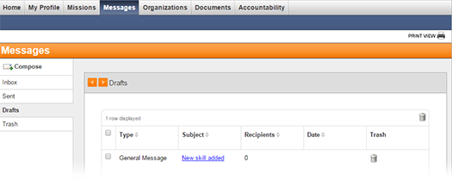
2. Take any of these actions.
If you want to... | Then...
Sort messages, | ● Click a column header (for example, Type, Subject, Sender, or Date). The messages are rearranged in alphabetical or ascending order depending on the contents.  ● Click the column header again to rearrange messages in the reverse alphabetical or descending order.
View the details of a message, | ● Click the linked Subject. The message opens.  ● Continue with the procedure to Preview and Test and/or compose and send the message.
Send messages to the Trash, | ● To send one message to the Trash, on that message row, click the delete icon .  ● To send multiple messages to the Trash, on each message row, select the check box. Then, on the upper, right of the table, click the trash icon .

Manage Trash Messages
Messages that you send to the trash are stored in the Trash folder until you restore or delete them. Messages in the Trash can be restored to the folder from which they originated or deleted to remove them from the system permanently. If necessary, deleted messages can be retrieved from the database by a system coordinator.
Note: The images in this procedure show the system as it appears by default, and the tabs, fields, and labels on your page may be different.
To view trash messages
1. Go to Messages, and on the left, click Trash.
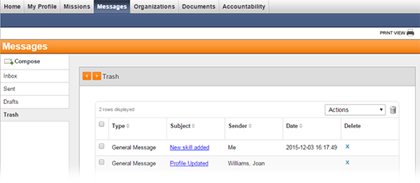
2. Take any of these actions.
If you want to... | Then...
Sort messages, | ● Click a column header (for example, Type, Subject, Sender, or Date). The messages are rearranged in alphabetical or ascending order depending on the contents.  ● Click the column header again to rearrange messages in the reverse alphabetical or descending order.
View the details of a message, | ● Click the linked subject. The message opens.  ● Optionally, take these actions:  ♦ In the Message Details section, for Response Options, select an available response and click Submit Response.  ♦ In the Actions menu, click to Restore or Delete the message.
Mark messages as read or unread, | ● On the row for each message that you want to mark, select the check box.  ● Then, in the Actions menu, click Mark as Read or Mark as Unread.
Restore messages, | ● On the row for each message that you want to restore, select the check box.  ● Then, in the Actions menu, click Restore.
Delete messages, | ● To delete one message, on that message row, click the delete icon X.  ● To delete multiple messages, on each message row, select the check box. Then, on the upper, right of the table, click the trash icon .

More Information
This section provides more details information on messages, delivery methods, statistics, templates, and more.

Recipient Containers
Containers are entities that are added to messages as recipients. Containers are created when the message is sent, and they are associated with messages to collect information about message delivery and recipient response statistics.
When creating a message, recipients are added as:
- Individuals
- Administrators
- Organizations
- Groups
- External Recipients
Recipients Added to a Message as: | Belong to Containers, such as:
Individuals | Individuals
Administrators | Individuals
Groups | Strike Team  Region 1  Region 2
Organizations | Associations  Department of Health  Mercy Hospital
External Recipients | External Recipients
On the Recipients Display Filter, containers are a field that can be used to filter or adjust results in the recipient list.

Delivery Methods
Message delivery methods include:
● Internal Message – Messages are delivered to the recipients' registered system. Depending on your system configuration, a notification about the internal message is sent to the recipients' primary email address. However, if multiple delivery methods are selected, then the notification is not sent to their email address.
● Email – Messages are delivered to the recipients' email address.
● Fax – Messages are delivered to the recipients' fax number.
● Text Message – Messages are delivered to the recipients' phone as an SMS/Text message.
● Pager – Messages are delivered to the recipients' pager number.
● Voice Notification – Messages are delivered to the recipients' primary phone number.
● Multiple Methods – Messages are delivered to more than one of the recipients' available contact methods.

Message Formatting
You have a number of formatting options available to you when building a notification's Message. You may be familiar with many of these options if you have used word processing software.
This topic provides an overview of the available formatting options, as shown in this image.
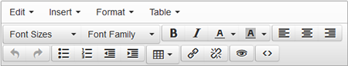
Read the following for information about:
● Menus and options
● Toolbar options
● Tips on formatting
● Example

Menus
Open each menu to see the options. Some of the options listed in the menus are also available via the icons in the formatting toolbars.
Item | Options | Descriptions
Edit | Undo, Redo | Undo your last action.  Redo the last action for which you clicked Undo.
 | Cut, Copy, Paste | Cut or copy content or paste content. Refer also to Tips, below.
 | Select All | Select all content in the message field.
Insert | Insert link | Create a link to a website/URL.
Tip: You must include http:// or https:// at the beginning of the website address/URL.
Tip: When inserting a hyperlink, consider setting Target to New window. When the user clicks the link in the received message, the website opens in a new tab or browser window (depending on your browser's settings). Also, if you click the link from within the Message Details of a Sent Message, the site opens in a new tab rather than within the CORES site window frame.
Format | Bold, Italic, Underline | Apply bold or italic typeface to the selected text or underline the text.
 | Clear formatting | Remove all formatting from the content.
Table | Insert table | Insert a table into the message by selecting the number of rows and columns.
 | Tip: When inserting a table, first enter text before and after the location where you plan to insert it so you do not lose track of your cursor.
 | Table properties | Open the table properties where you can specify a border, set up cell padding, or specify cell spacing. You can also change the height and/or width of the table, specify the alignment of content within the table, or add a caption above the table.
 | Delete table | Delete the table.
 | Cell | Open the cell submenu where you can merge cells or split a cell. In Cell properties you can change the height and/or width of the cell, the type of the cell, or the alignment of content within the cell. If you change the cell type to header, the text will be centered and bold typeface will be applied. All changes you specify in Cell properties window can be applied to one or more cells by defining the cell Scope.
 | Row | Open the row properties where you can insert a row before or after the row your cursor is in or delete a row. You can also specify the row height, the alignment of content within the row's cells, or specify the row type such as body, header, or footer.
 |  | Cut a row from the table, copy a row, or paste a cut or copied row before or after the row your cursor is in.
 | Column | Insert a column before or after the column your cursor is in or delete a column.

Toolbars
You can point to each area or icon in the toolbars to view a brief description of the formatting option.
Icons | Name | Descriptions
 | Font Sizes, Font Family | Change the font size.  Choose from a number of font families.
 | Bold, Italic, Text color, Text background color | Apply bold or italic typeface, change the text color, or change the background color for the text.
 | Align left, center, and right | Align the paragraph to the left margin, center, or right margin.
 | Undo, Redo | Undo your last action.  Redo the last action for which you clicked Undo.
 | Bullet list, Numbered list, Decrease indent, Increase indent | Apply a list format (bullet or numbered).  Decrease or increase a paragraph's indentation.
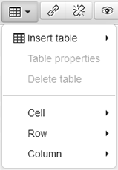 | Table | Insert a table by selecting the number of columns and rows to create.  Also apply other changes, such as inserting rows or columns, merging cells, or splitting a cell into multiple rows or columns.
 | Insert/edit link, Remove link | Insert a hyperlink or edit an existing hyperlink.  Remove a hyperlink.
 | Preview | Preview the formatting of the message. This allows you to see the message as it will appear to the message recipient.
 | Source code | View the message's formatting instructions (HTML markup), providing the ability to adjust the content by changing the HTML standard markup.

Tips

Copying and Pasting
Microsoft Word
You can copy and paste content from Microsoft® Office® applications—such as Word® or Excel®. The formatting Word includes is stripped from the content when you paste it into the message field. Certain aspects are retained such as paragraphs, headings defined with a Word heading style, and links.
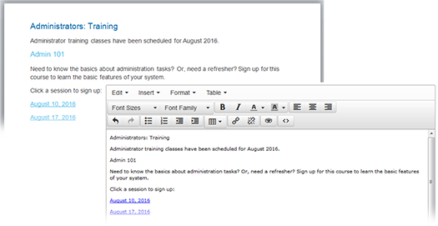
You can then apply the appropriate formatting to the message from within your system.
You can also specify the content should be pasted as plain text. In this case, all formatting is removed from the content, including paragraphs. The Paste as text option is available in the message Edit menu. Select that option and then paste the content into the message field.
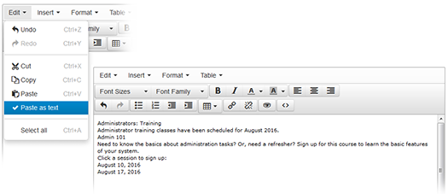
Note to Internet Explorer® users: If you copy and paste content into the message text box, IE may display a message indicating some content was blocked. Click the Allow blocked content option in the message. A window will open asking whether you want to leave the page. Click the Stay on this page option. Note that the IE message may take a few moments to close. Do not click Leave this page as you will lose all your work on this message.
Consider using the Preview and Test option. This action checks the message for invalid characters that may be inserted with the copied and pasted text. This invalid character check is also performed when you click Send. However, note that previewing the content using the Preview option in the rich text formatting toolbar does not trigger the invalid character check.
PDF
Be aware that the ability to copy and paste from a PDF into the Message field is not supported given the proprietary way PDFs are created. Therefore, copying and pasting directly from a PDF will not be successful. You may find that pasting the content in a text editor and then copying it into your message will work.

Source Code Option
Use the Source code option in the formatting toolbar to open the message's source code in a new window. You can check whether the message contains unwanted formatting.
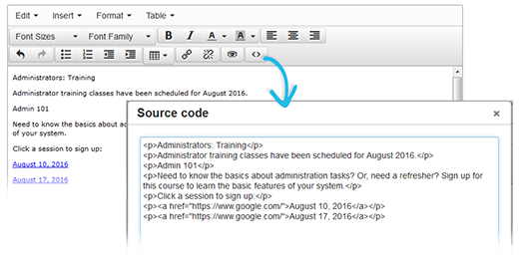
This option is especially helpful if you copied and pasted content from another source. You can also adjust the content by adding HTML standard markup.

Tables
When you add a table to a message, the table and cell borders you see are there to help you know where to add text. However, those lines are for editing purposes only. They are transparent in the previewed or sent message.
To add borders, insert the table in your message and place your cursor in it. Click the Table menu and then click Table properties. In Border, enter a value greater than zero and click OK. While still in editing mode, the table may not appear to change. To verify your change, simply click the Preview button to see how the table will look to the recipient.

Spell Check
Your browser's built-in spell check does not work in the Message field. Be sure to check your spelling.

Formatting Example
Following is an example of how a message looks while being configured. A few formatting options have been applied, including changes to font size and color, applying bold typeface to text, inserting a table, indenting content, and adding a hyperlink.
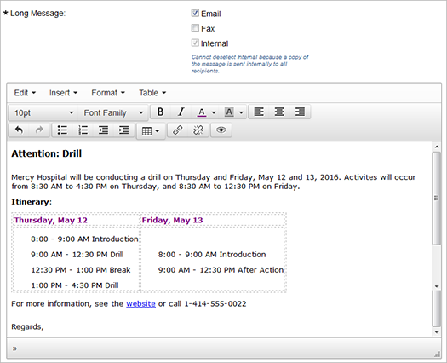
Clicking the preview icon allows you to see how the formatted content will look in the sent message.
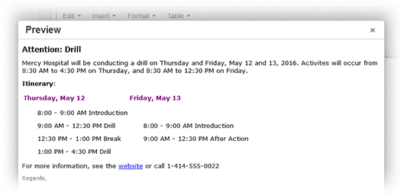
In this example, previewing the message may cause you to consider adding borders to the table in order to clarify columns and rows and the content in each. You may also decide to remove the indentation from the text within the cells. Following is the result of those changes.
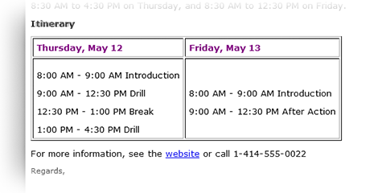

Voice Message Text-to-Speech Guidelines
This topic covers general and specific guidelines for using the text-to-speech technology when sending a voice message. This technology is employed by your system when you enter text in the Voice Message Body field when composing a message.
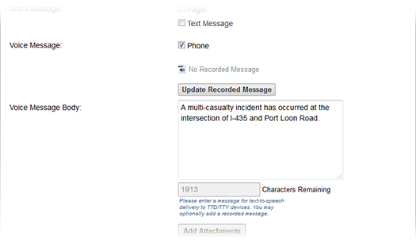
Carefully consider the information and level of detail to include when composing a message to be delivered as a phone call. The system employs text-to-speech technology that does not include voice inflection and can run your thoughts together, making it harder for recipients to understand the message. Using these guidelines, you can add "natural" pauses and take other steps to improve how your messages are read.

General Guidelines
You can control the speed at which the message is voiced by inserting the code \!rdxx in the message, where “xx” is the percentage of the standard speed. For example, inserting \!rd75 at the beginning of a message will cause it to be read at 75% of the standard speed.
You can also add pauses to your message. You can add a pause by inserting the command \!Pxxx, where “xxx” is the length of the pause in milliseconds. For example, inserting \!P500 before a phrase provides a 500 millisecond (.5 second) pause prior to that phrase. This type of command can be inserted anywhere within the message where a pause is needed.
In the following example, the first sentences will be voiced at 85% of the standard speed and the telephone number at 75%. The example also includes four 500 millisecond pauses:
\!rd85 The responder management system \!P500 has been activated due to a multiple casualty incident. \!P500 Your services may be needed for this incident. \!P500 Please respond with your availability. \!P500 You can also call the Emergency Operations Center at \!rd75 4125552122.

Detailed Guidelines
In most cases, the “General Guidelines” provide the information you need to create understandable voice messages. However, if you need to know specific information or have questions, this section provides details on how the system interprets specific types of text.*
*The detailed guidelines in this section are a subset of those listed in the document SVOX Speech Output SDK: Text Preprocessing Documentation – en-US 6.0.0, © 2001-2011 SVOX AG.

Acronyms
If an acronym is not part of an exception list, sequences of 2 to 3 uppercase letters are spelled out. Sequences that contain 4 or more uppercase letters are pronounced. Examples:
Text entered as... | The system reads as...
ERC | Spelled out as E R C
E R C | Spelled out as E R C
ERCs | Pronounced as a word
ERC's | Spelled out correctly
REMSC | Pronounced as a word
REMSCs | Pronounced as a word
R E M S Cs | Spelled out as R E M S C S
R E M S C's | Pronounced correctly
Web | Pronounced web
LONDON | Pronounced London
JOURNAL | Pronounced journal
ADSL | Spelled out as A D S L

Email Addresses and URLs
Domain names are pronounced properly, being either fully pronounced or spelled out. All punctuation marks included in the string are fully pronounced. Examples:
Text entered as... | The system reads as...
http://www.intermedix.com | W W W, dot, intermedix, dot, com
http://www.cnn.com/about_us | W W W, dot, C N N, dot, com, slash about, underscore, us
http://www.abc.org/~index | W W W, dot, A B C, dot, org, slash tilde index
paul.clark_2@cnn.com | paul, dot, clark, underscore, two, at, C N N, dot, com
v-williams@abc.go.com | V, dash, williams, at, A B C, dot, G O, dot, com
mike.smith@logo.com | mike, dot, smith, at, logo, dot, com

Phone Numbers
Generally, a phone number is read digit by digit including the country and area codes. Brackets around the area code and the symbol “+” (which introduces a country code) trigger a short pause. Characters used to separate groups of digits, such as a slash, hyphen, or whitespace, are not pronounced; a short pause is generated instead. Eleven digits is the longest sequence that is recognized as a telephone number. Examples:
Text entered as... | The system reads as...
(949) 699 2300 | Nine four nine, six nine nine, two three zero zero
978-977-2345 | Nine seven eight, nine seven seven, two three four five
+1 (408) 325-2200 | Plus one, four zero eight, three two five, two two zero zero
+44 1865 380990 | Plus four four, one eight six five, three eight zero nine nine zero

Dates
Short dates should be separated with dots or slashes, as in 1/1/16. Avoid hyphens as the numbers are likely to be interpreted as a range rather than a date. For months abbreviated to 3 characters, as in Jan or Feb, the full month will be pronounced. For days abbreviated to 3 or 4 characters, as in Mon or Thur, the full day will be pronounced. Examples:
Text entered as... | The systems reads as...
01/12/1992 | Twelfth of January nineteen ninety-two
1/12/92 | Twelfth of January nineteen ninety-two
24/02/11 | Twenty-fourth of February two thousand eleven
3/09/15 | Ninth of March two thousand fifteen
4/1/85 | First of April nineteen eighty-five
4.1.85 | First of April nineteen eighty-five
Mar. 9, 2011 | March ninth, two thousand eleven
wed 12.28.11 | Wednesday, twenty-eighth of December two thousand eleven
Thur. 12/29/2011 | Thursday, twenty-ninth of December two thousand eleven
Thur. 29-Dec | Thursday, twenty-ninth of December

Time
Time expressions are recognized whenever the number in the hour position is not greater than 24, and the numbers within the minutes and the seconds positions are not greater than 59. Seconds are optional. Time units (hours-minutes-seconds) must be separated by a colon, or an “h” when seconds are omitted.
A time expression can also include an indication about the part of the day or the time zone:
Time of the day:
● AM or am is spelled out
● PM or pm is spelled out
Time zones:
● EST is read Eastern Standard Time
● CDT is read Central Daylight Time
Examples:
Text entered as... | The systems reads as...
08:47 | Eight forty-seven
23:47:09 | Twenty-three forty-seven and nine seconds
9:23 am | Nine twenty-three A M
Fri, 11:47 PM | Friday, eleven forty-seven P M
14:30 PDT | Fourteen thirty Pacific Daylight Time
Sat. 10:45 AST | Saturday, ten forty-five Atlantic Standard Time

Measurements
Common measurement units are supported if they follow a number. Some exceptions apply, such as:
● In the case of very short units such as those that are typically one letter long.
● Where the reading might be ambiguous such as A, either the letter A or ampere; V, either letter V or volt.
● In the case of units that conflict with common acronyms and abbreviations.
Numbers supported are cardinal numbers, floats, signed numbers, and fractions. Examples:
Text entered as... | The system reads as...
38m | Thirty-eight meters
25 km | Twenty-five kilometers
-25° C | Minus twenty-five degrees Celsius
1,000 cm | One thousand centimeters
1,5 % | One comma five percent
1.5 MHz | One point five megahertz
125 m2 | One hundred twenty-five square meters
3 m/s | Three meters per second
20,9 mi | Twenty comma nine miles
32 yd | Thirty-two yards

Periods and Line Breaks
To ensure periods are not read as dot, copy and paste the unformatted voice message and then remove any line breaks.

Special Characters
The system recognizes some special characters and emoticons. However, it is best to avoid using these in alert messages.

Numbers: Cardinal
Numbers that are 0 through 9 digits in length are read as full numbers. Those with 9 digits or more are spelled out, or each digit is pronounced in isolation. Examples:
Text entered as... | The system reads as...
31 | Thirty-one
211323 | Two hundred eleven thousand three hundred twenty-three
631000745 | Six hundred thirty-one million seven hundred forty-five
237601983467 | Two three seven six zero one nine eight three four six seven
0012 | Zero zero one two
Numbers that include separators, such as a space, apostrophe, comma, or period, are recognized and pronounced correctly. Separators are allowed after each third digit, counting from right to left. Examples:
Text entered as... | The system reads as...
1,000,000 | One million
1 000 000 | One million
10,123,230 | Ten million one hundred twenty three thousand two hundred thirty

Numbers: Ranges
Range expressions are recognized when two numbers are connected by a hyphen. The hyphen is read as “to.” Only numbers up to 999 are supported. Examples:
Text entered as... | The system reads as...
10-20 | Ten, to twenty
120 - 451 | One hundred twenty, to four hundred fifty-one

Numbers: Float
The part before the decimal point is read following the rules for cardinal numbers. Numbers to the right of the decimal point are always pronounced digit by digit. The decimal point may be written as a comma or as a period. Examples:
Text entered as... | The system reads as...
1,23 | One comma two three
1.99 | One point nine nine
1.00 | One point zero zero
34.1056 | Thirty-four point one zero five six
1,003.00987 | One thousand three point zero zero nine eight seven
7,123.45 | Seven thousand one hundred twenty-three point four five
1,000,000.54 | One million point five four

Numbers: Ordinal
Numbers up to 999 followed by an ordinal suffix are pronounced as ordinals. The suffix, such as st, nd, rd, th, must be attached to the number. Examples:
Text entered as... | The system reads as...
1st | First
2nd | Second
23rd | Twenty-third
154th | One hundred fifty-fourth
9000th | Nine thousandth

Numbers: Roman Numerals
Roman numerals not followed by a dot are read as cardinal numbers, while those followed by a dot are pronounced as ordinals. Several exceptions apply due to ambiguities and frequent conflicts with acronyms such as I, V, C, D, L, M, X, CD, XL. Examples:
Text entered as... | The system reads as...
VII | Seven
IX | Nine
XXXI | Thirty-one
II. | Second
XI. | Eleventh
V | V
X | X
CD | C D spelled out

Organizations

My Organizations
The My Organizations tab allows you to view the organizations in which your membership has been accepted or is pending. To access this page, go to Organizations: My Organizations. The following page opens.
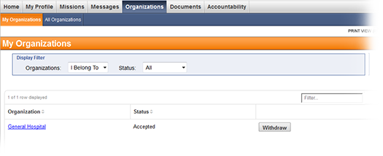

View My Organizations
To view the organizations you belong to or manage, go to Organizations: My Organizations. The following page opens.
You can quickly locate a specific organization by entering all or part of its name in the quick filter box on the upper right side of the table.
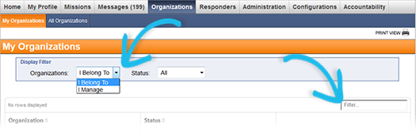
To manage your organizations:
● Use the options in Display Filter to change how the organizations are displayed on the page. In Organizations:
♦ Select I Belong To to display organizations you have joined.
♦ Select I Manage to show organizations you have rights to such as those you belong to or have created. You can click a number link corresponding to a specific status to view all members with that status.
● Use the Status filter to only display organizations you have a specific status for.
Tip: Select Withdrawn to show organizations you have withdrawn from.
● Use the Filter by Network filter, if available, to display specified organizations and their children in the table. If this feature is enabled on your system, you can specify the organizations that should appear in this filter in the Details page of an organization you manage.
● Click the Dashboard link to go directly to the organization's dashboard page.

Withdraw from an Organization
To withdraw membership from an organization:
1. Go to Organizations: My Organizations. The following page opens.
2. Select Belong To from the Display Filter.
3. Click the Withdraw button next to the organization you would like to withdraw from.

All Organizations
The All Organizations tab displays all organizations that you are authorized to view and the relations between them. To access this tab, go to Organizations: All Organizations. The following page opens.
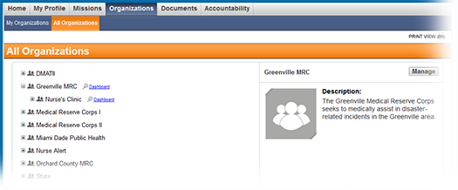
Tip: By selecting an organization, you can see its preview on the right.

Edit Organization Details*
* Note: You might not have sufficient access level permissions to perform this task.
To edit organization details
1. Go to Organizations: All Organizations.
2. Click the link next to the desired organization.
3. Click the Details side tab. The Details page opens.
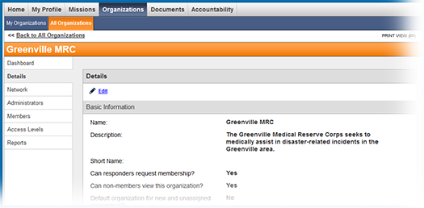
4. Click the link in the upper left corner of the page.
5. Edit the organization information:
Field | Description
Name | Specify a unique organization name. This field is limited to 50 characters.
Description | Provide a description of the organization. This field is limited to 250 characters.
Short Name | Specify the short name for the organization. This name might be used on any forms with a character limit.
Can responders request membership? | Specify whether responders can request membership in the organization when they register for the site or through the All Organizations page.
Can non-members view this organization? | Specify whether responders who are not members of this organization can see it on the All Organizations page.
Set as default organization for new responders? | If you select this check box, newly registered responders are automatically added to this organization according to the configuration of your system.
How many organizations may a responder join in this network? | Indicate how many organizations the responder can have membership in within an organization's network. This limit does not apply to a responder's pending memberships; it only applies to accepted memberships. Go to the Network side tab to view organizations within the network. Enter 0 for unlimited membership.
System Status | Use this option to retire the organization and end its activity. Before retiring an organization, transfer all members out of it.
Current Picture | Preview of the current picture.
Change Picture | Use the Browse button to select a picture, then click Upload to make the change. Use images in GIF or JPEG format no larger than 2 MB. Suggested width to height ratio is 3:4. Uploading images with different aspect ratio may result in distortion.
Email Address | Specify an email address you plan to use to communicate with responders.
Contact Method | Select preferred contact method.
Phone Number | Specify the contact phone number.
Address Line 1 and 2 | Provide the house number and the street name where the organization is located. If applicable, provide any additional address information.
City | Specify the city where the organization is located.
County | Specify the county where the organization is located.
State | Specify the state where the organization is located.
Zip Code | Specify the organization's zip code.
6. Click Save Changes to update the organization with the new information.

Manage Organization Members
Users belong to organizations as members to receive information and notifications related to that organization. A list of users that includes their membership status is available through the organization's Members page. Administrators are able to manage organization members and perform these functions:
● Add members
● View the membership change log
● Change members' statuses
● Transfer members
● Add members to groups
● Export members
To manage organization members
1. Go to Organizations: All Organizations. The All Organizations page opens.
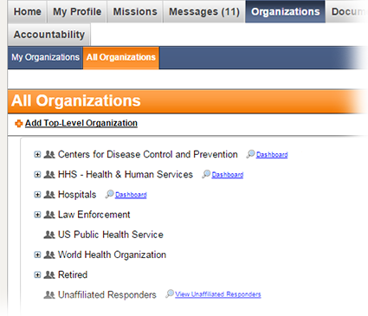
2. Locate the organization that you want to manage and on that row, click the dashboard icon. The organization's dashboard page opens.
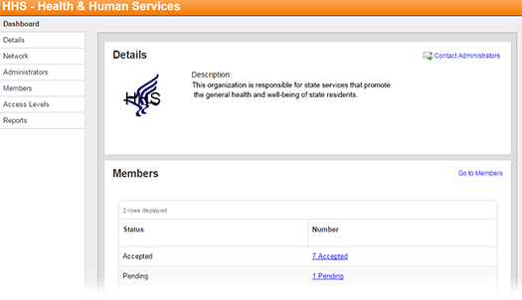
3. In the sidebar, click Members. The organization's Members page opens, and by default, members with the Accepted status appear in the table.
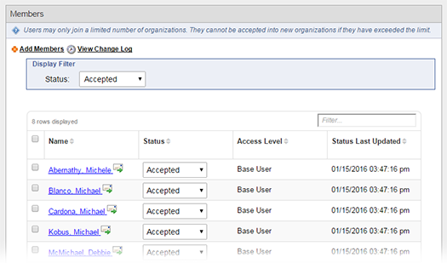
Tip: Alternately, from the dashboard, the Members page can be accessed through links in the Members section.
Note: The Name, Status, and Access Level columns are included in the table by default. Other columns may be present depending on your system and its configuration.
4. To filter members by status, in the Display Filter: Status menu, select a different status to view that subset of members.
5. Take any of these actions.
If you want to... | Then...
Add members, | ● Above the Display Filter, click Add Members. The Search Center window opens.  ● In the Search box, enter all or part of the user's name, and then click Search. The results appear in the window.  ● Locate and select the check box for users you want to add.  ● Click Add Responders. The window closes and users are added to the organization.  Note: By default, new users are given the Accepted status. Your system can be configured to use a different default status.
View member changes for the organization, | Above the Display Filter, click View Change Log. The organization's change log window opens.
Change members' statuses, | ● In the Display Filter: Status menu, click the current status of users whose status you want to change. The member table is updated.  ● Locate and select the check box for users whose status you want to change.  ● In the Select an action menu, click Set to Accepted, Set to Pending, Set to Rejected, or Set to Researching.  ● Click Submit Action. The member table is updated.  Tip: To quickly change the status of one user, locate the user and on their row in the Status menu, click the status that you want to assign them.
Transfer members, | ● Select the check box for users you want to transfer.  ● In the Select an action menu, click Transfer Responders.  ● Click Submit Action. The Organization Selection window opens.  ● Select the check box of the organization to which you want to transfer users.  ● Click Transfer and Notify or Transfer. The window closes and users are transferred to the other organization.  Tip: If you select Transfer and Notify, to send the message you still need to click Notify Administrator(s) in the action box that appears at the top of the page.  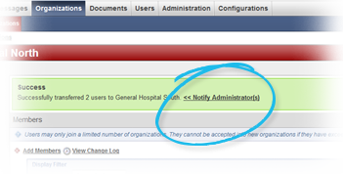
Add members to an existing group, | ● Select the check box for users you want to add to a group.  ● In the Select an action menu, click Add to Existing Group. The Group Name menu appears.  ● In the Group Name menu, click the name of the group to which you want to add the members.  ● Click Submit Action. Selected users are added to the group.
Create and add members to a new group, | ● Select the check box for users you want to add to a group.  ● In the Select an action menu, click Add to New Group. Three fields appear below.  ● For Group Name, type a name that you want to assign the new group.  ● For Viewable By, click an option to select who can view the group.  ● For Allow other administrators to make changes to or delete this group, click Yes or No.  ● Click Submit Action. Selected users are added to the group.
Export members, | ● Select the check box for users you want to export.  ● In the Select an action menu, click Export as CSV (Excel).  ● Click Submit Action. The Export page opens and provides information about the export status.

Create an Access Level*
* Note: You might not have sufficient access level permissions to perform this task.
To create an access level
1. Go to Organizations: All Organizations.
2. Click the link next to the desired organization.
3. Click the Access Levels side tab. The following page opens.
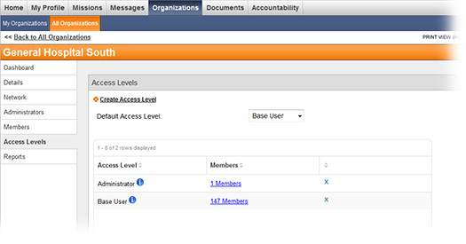
4. Click Create Access Level in the upper left corner.
5. In the window that opens, complete the appropriate fields:
Field | Description
Name | Specify access level name.
Make organization administrator? | Specify whether members with this access level are considered organization administrators and should receive Contact Us emails for the organization. An organization may have more than one access level that allows members to be administrators.
View Reports | Select this check box to allow members with this access level to view reports for this organization and its child organizations.
View Members | Select this check box to allow members with this access level to see names of all members of this organization and any child organizations.
Message Members | Select this check box to allow members with this access level to send messages to members of this organization and any child organizations. Members with this access level may also view templates and groups only viewable by organization administrators. For this permission to be fully effective, you also need to select View Members.
Transfer Members | Select this check box to allow members with this access level to transfer members into and out of this organization and any child organizations. For this permission to be fully effective, you also need to select View Members.
Manage Members | Select this check box to allow members with this access level to add members, accept membership requests, set membership status, and add members to access levels. For this permission to be fully effective, you also need to select View Members.
Manage Access Levels | Select this check box to allow members with this access level to create and edit access levels as well as assign access levels to members. For this permission to be fully effective, you also need to select View Members.
Edit Organization | Select this check box to allow members with this access level to edit details of this organization and any child organizations. Members can also manage the organizational network.
6. Click Save.

Manage Access Levels*
* Note: You might not have sufficient access level permissions to perform this task.
To view organization access levels
1. Go to Organizations: All Organizations.
2. Click the link next to the desired organization.
3. Click the Access Levels side tab. The following page opens displaying access levels that exist in the organization.
To set default access level
On the Access Levels page, select the desired default access level from the drop-down list. All accepted and added members are automatically placed into this access level. Typically, the default access level is Base User.
To edit access level details
To edit access level details:
1. On the Access Levels page, click next to the desired access level. The access level details window opens.
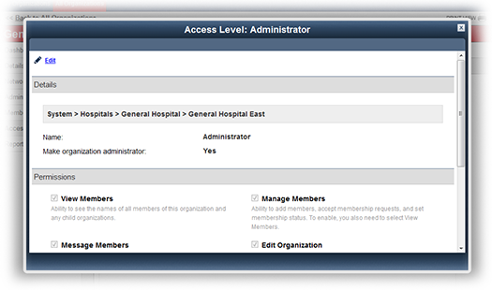
2. Click Edit in the upper left corner.
3. Edit access level details.
4. Click Save.
To delete access levels*
* Note that you might not have permissions to perform this action.
Before you delete an access level, be sure to reassign the users to a different access level. All users who have not been reassigned are automatically unassigned from the access level after you delete it. Note that these users will remain organization members.
To delete an access level:
1. Go to the Access Levels page.
2. Click the X button in the Delete column.
3. Click Delete in the confirmation window.

Add Members to Access Levels
Note: You must first add members to an organization before you can add them to an access level. The members are first assigned to the default access level, but they can be reassigned if necessary using the instructions below.
To add organization members to an access level from the Access Levels page
1. Go to Organizations: All Organizations.
2. Click the link next to the desired organization.
3. Click the Access Levels side tab. The following page opens.
4. On the Access Levels page, click # Members in the Members column.
5. On the page that opens, click Add Members in the upper left corner.
6. Select the members you want to add.
7. Click Add Members.
To set access levels for multiple members at once from the Members page:
1. Go to Organizations: All Organizations.
2. Click the link next to the desired organization.
3. Click the Members side tab. The Members page opens.
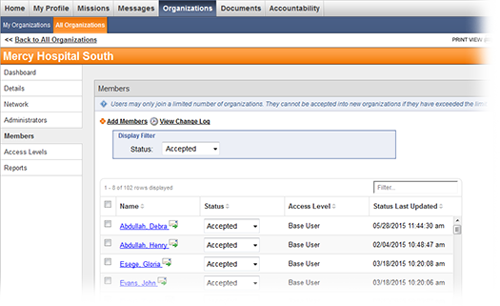
4. Select check boxes next to the responders' names.
5. From the Action drop-down menu in the lower left corner of the page, select Set Access Level.
6. Click the Submit Action button.
7. In the window that opens, select the desired access level from the drop-down list.
8. Click Save.

Manage Network*
* Note that you might not have sufficient access level permissions to perform this task.
To view an organization's network
1. Go to Organizations: All Organizations.
2. Click the Dashboard link next to the desired organization.
3. Click the Network side tab. The following page opens, displaying the organization's parents and children.
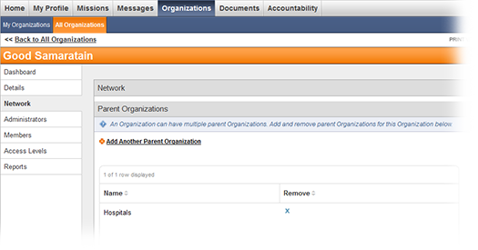
To add a parent organization
1. Click the Add Another Parent Organization link.
2. Click the Select button next to the desired parent organization. The selected organization appears in the Parent Organizations table.
To remove a parent organization, click the button on the right side of the Parent Organizations table. The System organization is the highest level organization and always appears in this list.
To add child organizations
To add a child organization:
1. Click the Add Another Child Organization link.
2. Click the Select button next to the desired child organization. The selected organization appears in the Child Organizations table.
To remove a child organization, click the button on the right side of the Child Organizations table.

View and Message Organization Administrators
To view organization administrators
1. Go to Organizations: All Organizations.
2. Click the link next to the desired organization.
3. On the page that opens, click the Administrators side tab. The Administrators page opens displaying current organization administrators.
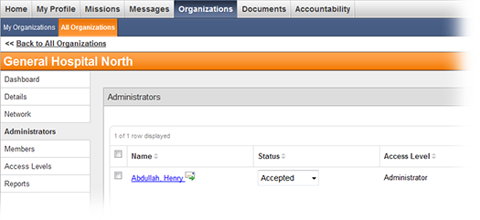
Tip: Use the message icon next to an administrator's name to contact the administrator.

Join an Organization
To join an organization
1. Go to Organizations: All Organizations.
2. Select an organization by clicking its name. Organization preview appears on the right.
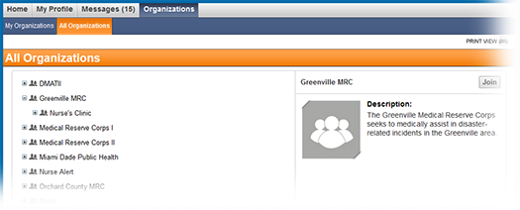
3. Click the Join button in the preview section. Your membership request is sent to the organization administrator.
Note: If the Join button is not available, you might not have permissions to join the organization or you may have exceeded the limit for organizations you can join in this network.

View Reports*
* Note: You may not have access to the Reports tab depending on your access level permissions. If you have access, the reports that appear are dependent on your system configuration.
To view reports for an organization
1. Go to Organization: All Organizations.
2. Click the Dashboard link next to the appropriate organization.
3. Click the Reports side tab. The following page opens.
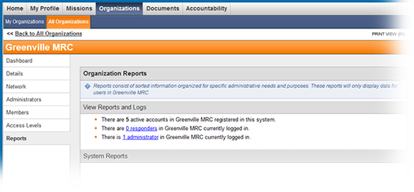
4. Click a report name to view information for the organization.
Note: System reports are located in Administration: Reports.

Organizations Overview
Organizations represent official groups and agencies that responders are affiliated with, such as community centers or health care facilities. Organizations are arranged in this module in a hierarchy that reflects real-life structures and relations between organizations. Only responders with the highest level of permissions, such as System Coordinators, can create organizations. Responders with appropriate system roles can manage an organization's hierarchy, or network, and view responders who are not affiliated with any organizations.
Top-level organizations represent entities of the highest level and authority. Sub-organizations represent their “children.” For example, if the National MRC is a top-level organization, then the MRC of Southwestern Pennsylvania will be its child.

Organization Administrators
Each organization has administrators who are responsible for managing the organization's information and members. The organization creator designates administrators and defines the actions they can perform. Organization administrator permissions are managed using access levels.
Organization administrators also serve as points of contact for other members.

Joining an Organization
You can join most organizations to have access to their information and receive message updates. When you click the Join button, your membership request is sent to the organization administrator for approval.
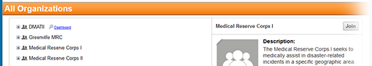
Note that if the Join button is not available, you might not have permission to join that organization. In this case, you can only become a member if the administrator adds you.
Organization member permissions are also managed using access levels.

Organization Membership Status
The organization membership status indicates whether responders are accepted into an organization. The Members page of a selected organization displays its members and responders who have requested membership in this organization.
An administrator can change a responder's organization membership status. These statuses should be used to show the user and other administrators the action taken on the submitted request. The statuses are explained below.
● Accepted - the responder has been accepted into the organization and can view organization details and contact information.
● Rejected - the administrator has denied the responder's request to join the organization.
● Pending - the administrator has not taken any action on the responder's request to join the organization. This status is set automatically for all new requests.
● Researching - the administrator is gathering additional information to determine whether the responder's organization affiliation is authentic.

Access Levels
Access levels are permission sets that allow members to perform different tasks within an organization. By assigning organization members to access levels, you determine the information they can see and actions they are allowed to perform.
Important: Access levels are not system roles. Permissions given to responders by access levels only apply to the specific organizations in which the access level permissions were granted.
New organization members are automatically added to the default access level. Users with the Manage Access Levels permission can assign members to a different access level after they are accepted. An organization member can only be assigned to one access level.
Each organization comes with two standard access levels: Administrator and Base User. You can create, modify, and delete access levels. When you create a child organization, it has the same access levels as its parent.
Note: If a child organization already exists, and you create a new access level in the parent organization, the new access level is not created in the child organization.

Network
An organization's network represents both the parent and child organizations of the selected organization. From the Network side tab, you can add or delete parent and child organizations. The changes you make on this tab are also visible in the All Organizations page.

Documents
The Documents tab provides access to a number of features.
For detailed information, refer to:
● Document Library
● My Documents
● My Watched Documents
● Document Search

Document Library
* Note that Document Library is an optional module that can be purchased. You may not have access to this module on your system.
The Document Library is a repository for documents that you want share with other users. You can create folders and add files to the system for other users to view and download. Another way of adding documents to the library is to export sent messages from the Messaging module.
Access to folders and files within the library is determined by user permissions.
To access Document Library, go to Documents: Document Library. The following page opens.
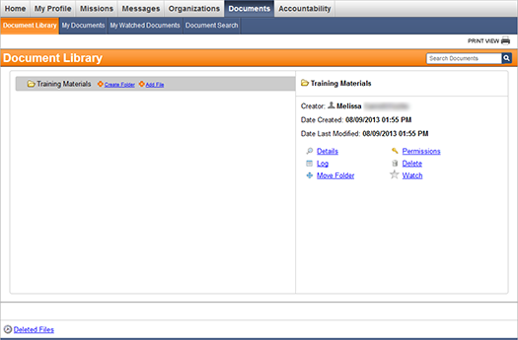
Choosing to export sent messages to the Document Library creates a new folder, named Sent Messages, and folders for exported messages are saved within that folder. Messages are saved in comma separated values (.csv) and portable document format (.pdf) files within the message folder. Additional folders for each message container are also saved within the message folder, and the message files are nested within these folders.
To quickly locate files within the Document Library, use the search bar on the right of page header. Enter the alias, filename, or author that you want to locate, and click the search icon.
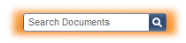

Manage Documents*
* Note: You might not have permissions to perform all actions described on this page.
To view documents, go to Documents: Document Library. The following page opens.
You can arrange files and folders in a hierarchy for easier management. Add top-level folders, subfolders, and upload files anywhere in the hierarchy. To see the contents of the individual folders, click the plus icon to the left of the folder's name to expand it.
Click a folder or file name to open the preview pane on the right. Click the Details link in this pane to see the details of a folder or file.
Tip: View the My Documents tab to only see documents you have uploaded, checked out, or checked in.

Create a Folder*
* Note that you must have the Read and Update permissions in the parent folder to create a subfolder.
To create a subfolder
Important: You should add folder permissions for a top-level folder before adding a subfolder. Otherwise, the subfolder will not inherit the parent folder's permissions unless you cascade permissions.
1. Go to Documents: Document Library. The following page opens.
2. Click the Create Folder button to the right of the appropriate parent folder.
3. In the window that opens, ensure the gray box displays the desired hierarchy.
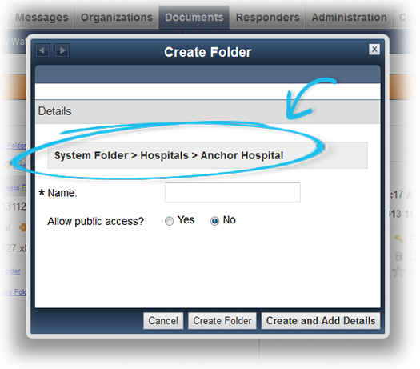
4. Specify a folder name.
5. Select an option for Allow public access? to indicate whether the folder should be visible to all system users.
Important: The Allow Public Access setting on a file or folder in the Document Library provides any registered user read-only access to the item. Users are not permitted to modify the file or folder, or upload a new version of the file without additional permissions.
6. Perform one of the following actions:
● Click Create Folder to add the folder to the Document Library.
● Click Create and Add Details to add folder details.
To create top-level folders*
* Note: Only System and State Administrators can create a top-level folder.
To create a top-level folder in the Document Library:
1. Go to Documents: Document Library.
2. Click the link in the upper left corner of the page.
3. Specify a folder name.
4. Select an option for Allow public access? to indicate whether the folder should be visible to all system users.
5. Perform one of the following actions:
● Click Create Folder to add the folder to the Document Library.
● Click Create and Add Details to add folder details.

Manage Folder Details*
* Note: You must have Read and Modify permissions to perform this action. Additionally, you may have permissions to edit some folders but not others.
To view and edit folder details
1. Go to Documents: Document Library and click the folder name.
2. Click the Details link in the preview pane on the right. The following page opens.
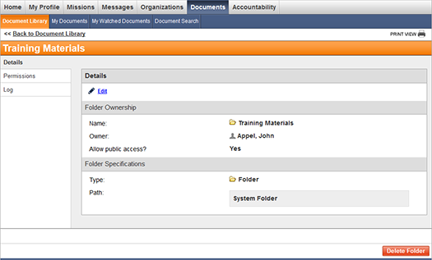
3. Open the folder details page.
4. In the upper left corner, click the Edit link.

5. Edit folder details (see field descriptions below).
Field | Description
Name | Specify a folder name.
Owner | This field displays the name of the person who has primary responsibility for the folder. You can click the Change link to select a new owner, if necessary.
Allow public access | If you want all users to be able to view the folder, click the Yes option. This action designates the folder as Public so that users without set permissions can view it. By default, this field is set to No.
Type | This field specifies whether the item is a folder or a file and cannot be edited.
Path | This field displays where the folder is located. Note that System Folder represents the top level.
Tip: Use the Delete Folder button to delete the folder.
6. Click Save to save your changes.

Add a File*
* Note: You must have Read and Update permissions in the parent folder to perform this action.
To add a new file to an existing folder
Important: You should add folder permissions before adding files to your folder. Otherwise, any files you add will not inherit the folder's permissions unless you cascade permissions.
1. Go to Documents: Document Library. The following page opens.
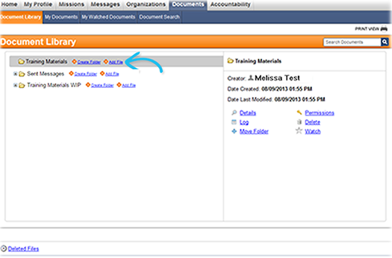
2. Click the Add File link to the right of the folder name. The following window opens.
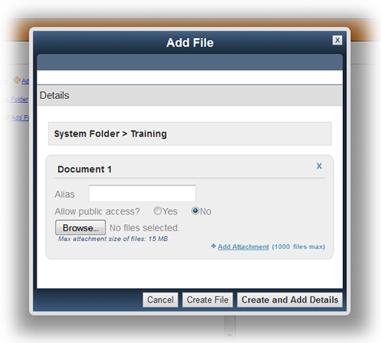
3. Click Browse or Choose File to select the appropriate document.
4. Specify an alias for the file. The alias is used in document searches and is displayed as the filename.
5. Select an option for Allow public access? to indicate whether the file should be visible to all system users.
Important: The Allow Public Access setting on a file or folder in the Document Library grants read-only access to registered users. Users are not permitted to modify the file or folder, or upload a new version of the file without additional permissions.
6. If necessary, click the Add Attachment link to upload multiple files at one time.
7. Perform one of the following actions:
● Click Create File to add the file to the Document Library.
● Click Create and Add Details to open the Details page and add the author's name, keywords, or a description.

To add a file to the top level*
* Note: Only System and State Administrators can add a file to the top level.
1. Go to Documents: Document Library.
2. Click the Add File link in the upper left corner of the page.
3. Click Browse or Choose File to select the appropriate document.
4. Specify an alias for the file. The alias is used in document searches and is displayed as the filename.
5. Select an option for Allow public access? to indicate whether the file should be visible to all system users.
6. If necessary, click the Add Attachment link to upload multiple files.
7. Perform one of the following actions:
● Click Create File to add the file to the Document Library.
● Click Create and Add Details to add the author's name, keywords, or a description.

Manage File Details*
* Note: You must have Read and Modify permissions to perform this action. Additionally, you may have permissions to edit or delete some files but not others.
To see and edit the details of a file
1. Go to Documents: Document Library.
2. Locate the appropriate file in the hierarchy and click its name.
3. Click the Details link in the preview pane on the right. The following page opens.
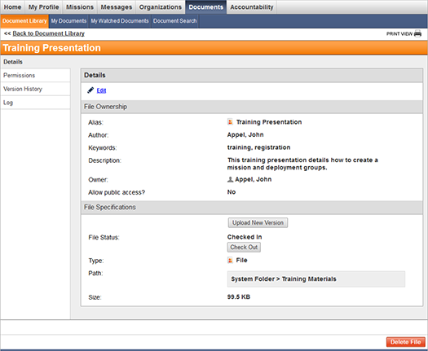
4. In the upper left corner, click the Edit link.
5. Edit the file's details as appropriate:
Field | Description
Alias | Specify a file name or alias that appears as the title of the file in the document library. Aliases are used in document searches.
Author | Specify who created the file. The author's name is used in document searches.
Keywords | Specify any keywords for the file. Keywords are used in document searches.
Description | Enter a description of the file.
Owner | This field displays the name of the person who has primary responsibility for the file. You can click the Change link to select a new owner, if necessary.
Allow public access | If you want all users to be able to view the file, click the Yes option. This action designates the file as Public so that users without set permissions can view it. By default, this field is set to No.
Upload New Version | This button allows you to upload a new version of the file. It is not visible when editing file details.
File Status | Displays whether the file is checked in or checked out. Click the Check Out button to check the file out for editing or click the Check In button to return the edited file. Click the Clear button to unlock the file for editing. File status is not visible when editing file details.
Type | This field displays whether the item is a folder or a file and cannot be edited.
Path | This field displays where the file is located. Note that System Folder represents the top level.
Size | This field displays the file size and cannot be edited.
Tip: Use the Delete File button to delete the file if you have permissions to do so.
6. Click Save.

Check Files In and Out*
* Note that you must have Read and Update permissions for the file to perform this action.
Use the file check-in and check-out feature to manage edits to your documents.
To check files out
1. Go to Documents: Document Library.
2. Locate the appropriate file and click its name.
3. Click the Details link in the preview pane on the right. The following page opens.
4. Click the Check Out button.
Tip: If you have checked out a document and do not want to upload a new file to check in, click the Clear button. This action unlocks the document and permits other users to check it out.

To check files in
1. Go to Documents: Document Library.
2. Locate the appropriate file and click its name.
3. Click the Details link in the preview pane on the right.
4. Click the Check In button.
5. In the window that opens, click Browse, then select the updated document.
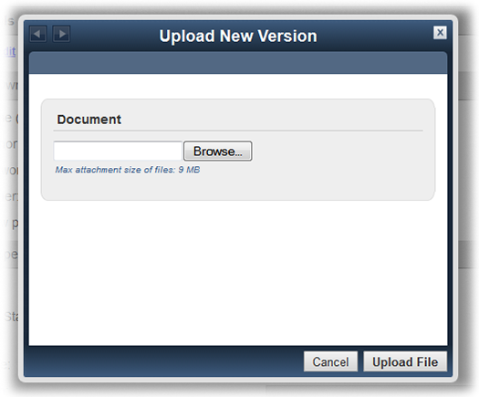
6. Click Upload File.
After you check a file back in, it becomes a new version of the file and is added to the Version History side tab.

Manage File Versions*
* Note: You must have Read and Update permissions for the file to perform this action.
To upload a new file version
1. Go to Documents: Document Library.
2. Locate the appropriate file and click its name.
3. Click the Details link in the preview pane on the right. The following page opens.
4. Click the Upload New Version button.
5. Click Browse and select the file.
6. Click Upload File.
Tip: Click the Version History side tab to quickly view the version history of the current file.
To view the version history of a file
The Version History page displays the previous versions of the file and includes the upload date, version number, file size, and file owner.
1. Go to Documents: Document Library.
2. Locate the appropriate file and click its name.
3. Click the Version History link in the preview pane on the right. The following page opens.
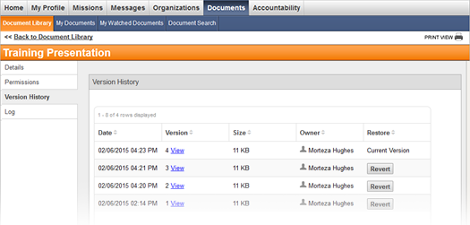
4. Click the View link to download a previous version of the file.
To revert to a previous version
1. Go to Documents: Document Library.
2. Locate the desired file and click its name.
3. Click the Version History link in the preview pane on the right.
4. Click the Revert button in the Restore column of the version you want to revert to.

Download a File
To view the contents of a file, you must first download it.
To download files
1. Go to Documents: Document Library. The following page opens.
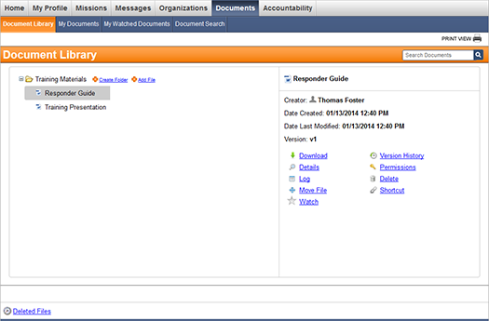
2. Locate the desired file and click its name.
3. Click the Download link in the preview pane on the right.
4. Follow browser prompts to open or save the file.

Manage Permissions*
* Note that you must have Read and Modify permissions for the file or folder to perform this action.
To add permissions to a folder or file
1. Go to Documents: Document Library.
2. Click the file or folder name.
Important: If you are adding permissions for responders to a file or subfolder within a parent folder, you should add permissions for the responders to the parent folder first.
3. Click the Permissions link in the preview pane on the right. The following page opens.
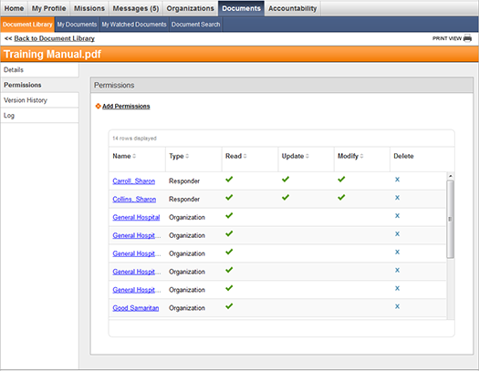
4. Click the Add Permissions link in the upper left.
5. Select an option at the top of the window to specify who the permission is added for.
Note: If you choose Organization or Access Level, skip to step 7.
6. Enter a search term, then click Search.
7. Select the desired responders, administrators, groups, organizations, or access levels.
8. Click Save and Choose Permissions. The following window opens.
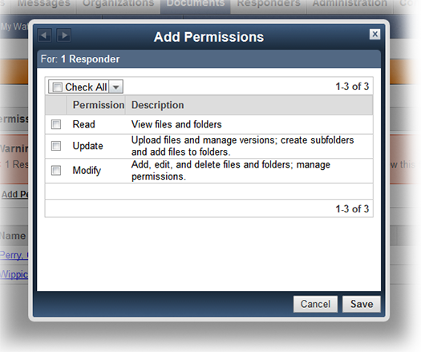
9. Select the check boxes next to the appropriate permissions.
10. Click Save.
If you receive an error message warning you that the responder does not have permissions within the parent folder, you must add the same permissions to the parent folder before the responder can have access to the file or subfolder.

To modify permissions
1. Go to Documents: Document Library.
2. Click the file or folder name.
3. Click the Permissions link in the preview pane on the right. The following page opens.
4. Click the appropriate link in the Name column.
5. In the window that opens, select additional permissions or clear existing permissions.
6. Click Save.
Tip: Click the X icon in the Permissions table to delete permissions.
To cascade permissions
Cascading permissions in a folder assigns the folder's permissions to all of its contents. System and State Administrators can perform this action to reset permissions on all folder contents and ensure all of the permissions are consistent.
Important: Cascading permissions overrides any specific permissions already assigned to a file or subfolder.
To cascade folder permissions:
1. Go to Documents: Document Library.
2. Click the folder name.
3. Click the Permissions link in the preview pane on the right.
4. Click the Cascade Permissions link on the bottom left of the page.
5. Click Confirm in the window that opens.

Delete Folders and Files*
* Note that you must have Read and Modify permissions for the file or folder to perform this action. Additionally, you may have permissions to delete some files and folders but not others.
To delete folders and files
1. Go to Documents: Document Library.
2. Click the folder or file name.
3. Click the Delete link in the preview pane on the right.
4. In the window that opens, click the Delete button.
To restore deleted files
1. Go to Documents: Document Library.
2. Click the link on the bottom left corner of the page.
3. Click the Restore link next to the file you would like to restore.
4. Click Restore to confirm. The file appears in the Document Library in its original location.
Note that you may not have the correct permissions to restore deleted files.

View Folder and File Logs
To view folder and file logs
1. Go to Documents: Document Library.
2. Click the folder or file name.
3. Click the Log link in the preview pane on the right. The following page opens.
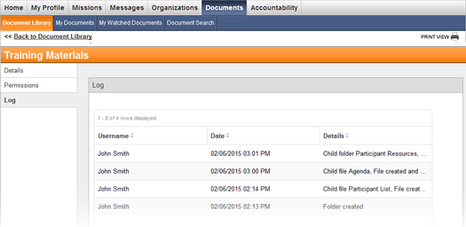
The Log page displays a list of actions that were performed on the folder or file. The table lists the username of the person who performed the action, the date and time the action was performed, and the action details.

Move Folders and Files*
* Note: You must have Read and Modify permissions for the file or folder, the parent folder, and the destination folder to perform this action.
To move a folder or file to another location
1. Go to Documents: Document Library.
2. Click the name of the folder or file.
3. Click the Move Folder or Move File link in the preview pane on the right. The Move window opens.
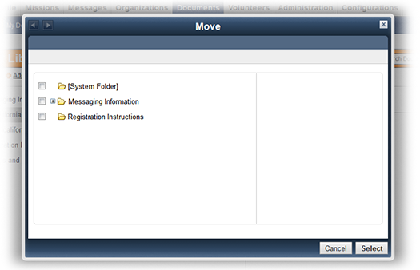
4. Select the folder you want to move the file or folder to.
Tip: Select [System Folder] to move the file or folder to the top level.
5. Click Select.

Create a Shortcut*
* Note: You must have Read and Modify permissions for the file, the parent folder, and the destination folder to perform this action.
To create a file shortcut
1. Go to Documents: Document Library.
2. Click the name of the file.
3. Click the Shortcut link in the preview pane on the right. The Create Shortcut window opens.
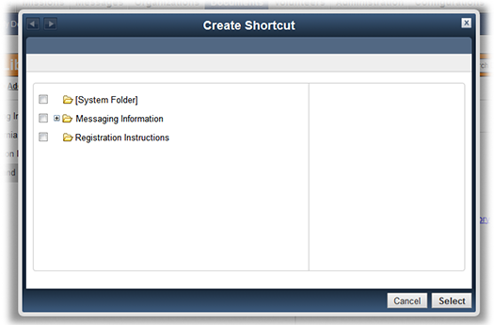
4. Select the folder to create a shortcut in.
Tip: Select [System Folder] to create a shortcut on the top level.
5. Click Select.
You can click the shortcut name and click the link in the preview pane on the right to delete a shortcut.

Watch Folders and Files
To watch a folder or file
1. Go to Documents: Document Library. The following page opens.
2. Click the name of the folder or file.
3. Click the link in the preview pane on the right.
You can view these documents in the My Watched Documents tab.
Tip: To stop watching a file or folder, click the link in the preview pane on the right.

Permissions
Folders and files in the Document Library have permission settings which determine whether you can view, edit, manage, add, or delete the documents.

State and System Administrator Permissions
If you have a System Administrator or State Administrator role, you are automatically granted all permissions for all files and folders.
Also, only a System or State Administrator can perform the following actions:
● Cascade a folder's permissions to all of its contents.
● Create top-level folders and add files to the top level.

General Permission Options
Administrators can give permissions to individual responders, administrators, organizations, and access levels. For example, if a Read permission is given to a responder, that individual can see the folder or file. If the Read permission is given to an organization, the folder or file becomes visible to every organization member.
The following list describes the permission options of Read, Update, and Modify.
● The Read permission allows responders to view the file or folder and its contents as well as download the files from the folder.
● The Update permission allows responders to create subfolders and add files. They can also manage file versions as well as check files in and out. In order for the Update permission to work, you need to select the Read option as well.
● The Modify permission allows responders to delete the file or folder and its contents as well as manage file details and folder details. They can also manage permissions and restore deleted files. In order for the Modify option to work, you need to select the Read option as well.
The following table describes permissions needed to complete each action.
Action | Permissions in Individual File/Folder |  |  | Permissions in Parent Folder
 | Read | Update | Modify | Read | Update | Modify
View File or Folder | X |  |  | X
Add File or Create Folder |  |  |  | X | X
Delete File or Folder | X |  | X | X |  | X
Restore File | X |  | X | X |  | X
Check Files In and Out | X | X
Move File or Folder* | X |  | X | X |  | X
Create File Shortcut* | X |  | X | X |  | X
Edit File or Folder Details | X |  | X
Manage File Versions | X | X
Change File and Folder Permissions | X |  | X
* In order to perform these actions, a user must have the same permissions for the destination folder.

File Check-in and Check-out
The file check-in and check-out feature allows you to prevent multiple individuals from editing a file at the same time.
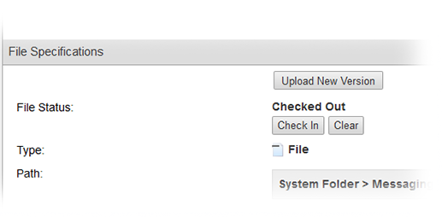
While the file is checked out, anyone can still download the file. You are prompted to upload the edited file when you check it back in. If you decide not to edit the file, you can click the Clear button to unlock the file and enable other responders to check it out.

File Shortcuts
When you create a file shortcut, it allows the file to be accessed from several places in your Document Library without making a copy of the file. The shortcut contains the same permissions as the original file so that responders can perform the same actions that they can perform on the original file such as:
● Download the file
● View and manage file details
● Start watching the file
You cannot manage file permissions or view a file's version history or log through a shortcut.
Note: If a file is deleted, all shortcuts are removed from the Document Library.

My Documents
The My Documents tab only displays the files that you have uploaded, checked out, or checked in. To access your documents, go to Documents: My Documents. The following page opens.
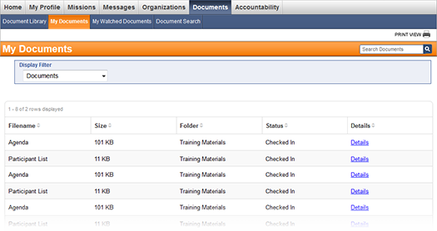
The My Documents table displays the file name, the file size, the folder where the file resides, whether the file is checked in or out, and a Details link that opens the file's Details page.
Use Display Filter to change how the documents are displayed on the page.
● The default Documents filter displays files you have uploaded to the Document Library.
● The Checked-out Documents filter displays files you currently have checked out of the Document Library.
● The Checked-in Documents filter displays files you have checked in to the Document Library.

My Watched Documents
You can watch a file or folder to receive email updates when the contents or details are modified.
To view watched documents, go to Documents: My Watched Documents. The following page opens.
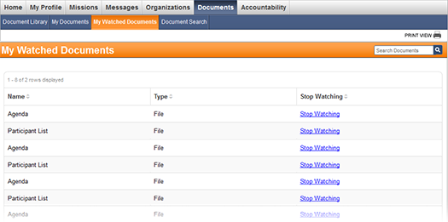
Tip: To stop watching a file or folder, click the Stop Watching link.

Document Search
The Document Search tab allows you to perform an advanced search within the Document Library.
To search for documents in Document Library
1. Go to Documents: Document Search. The following page opens.
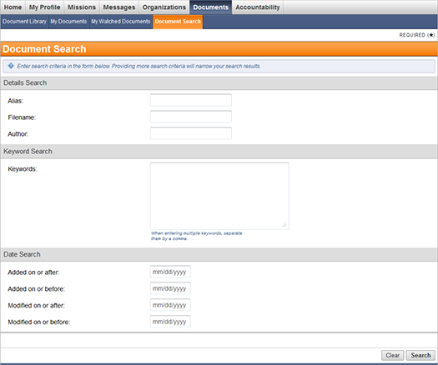
2. Enter the search criteria, such as the document alias, filename, or author.
3. Enter any search keywords.
4. In the Date Search section, enter any dates which apply to the document.
5. Click Search.
6. On the page that opens, click the Details link of a document to open the document's Details page.
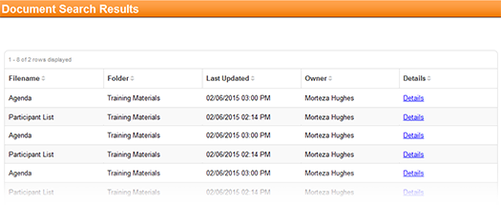

Accountability
You can create and manage time and attendance and your status from the Accountability tab.
* Note: Accountability is an optional module that can be purchased. You may not have access to this module on your system.
For more information and step-by-step procedures, refer to the following:
● My Status
● Time & Attendance

Time & Attendance
The Time & Attendance tab allows you to manage responder on-scene time and attendance by location. To access this tab, go to Accountability: Time & Attendance.
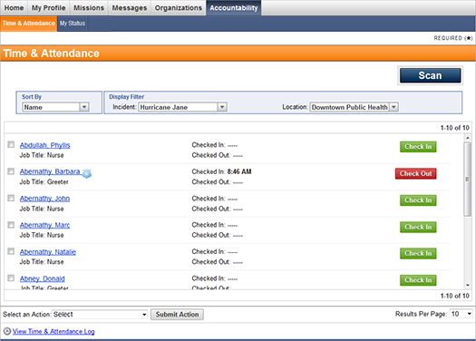
Under this tab, you can check responders in and out of a location and scan their badges.

Check Responders In and Out
To check responders in or out at a location
1. Go to Accountability: Time & Attendance. The following page opens.
2. Using Display Filter, select the desired incident and location.
3. Click the Check In or Check Out button corresponding to each responder you want to update.
Note: If you are assigned to an incident as a responder, you can check yourself in and out.

View Time and Attendance Log
To view the Time & Attendance Log
1. Go to Accountability: Time & Attendance. The following page opens.
2. Click the link at the bottom of the page. The following page opens.
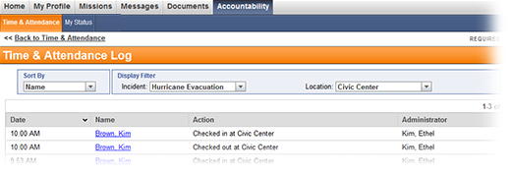
● Use the Sort By menu to sort the log entries by date, responder name, action, or administrator. It is also possible to sort by clicking on each column header.
● Use Display Filter to filter the log by incident and location.

Change Deployment Status
To change a responder's deployment status
1. Go to Accountability: Time & Attendance. The following page opens.
2. Using Display Filter, select the desired incident and location.
3. Click the responder's name to open his or her User Quick View window.
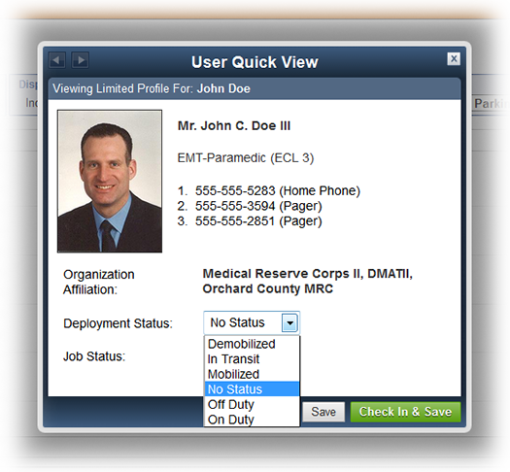
4. Select the desired status in the Deployment Status drop-down list.
5. Click Save or Check In & Save if you want to also check the responder in.
Note: If you are assigned to an incident as a responder, you can change your own deployment status.
To change the deployment status for multiple responders
1. Go to Accountability: Time & Attendance.
2. Using Display Filter, select the desired location and incident.
3. Select the desired responders from the list.
4. Select Change Deployment Status from the Select an Action drop-down menu.
5. Click Submit Action. The Change Deployment Status window opens.
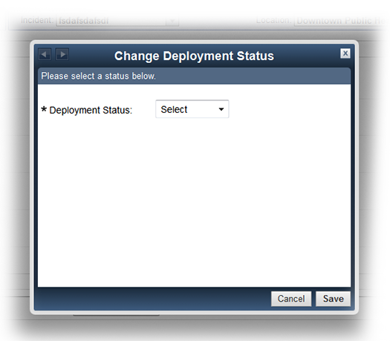
6. Select the desired status from the drop-down menu, then click Save.

Assign Responders to Jobs*
* Note: You may not have the appropriate permissions to perform this task.
Before assigning a responder to a job, you must first add incident jobs.
To assign a responder to a job
1. Go to Accountability: Time & Attendance.
2. Using Display Filter, select the desired incident and location.
3. Click the responder's name to open their User Quick View window.
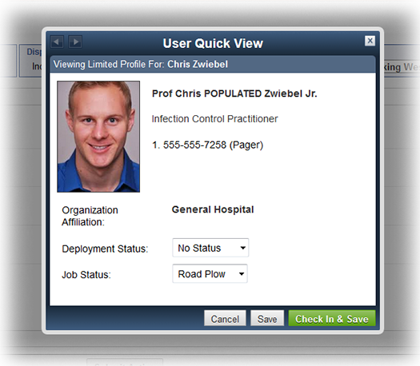
4. Select the desired job in the Job Status drop-down list.
5. Click Save.

Scanning Responder Badges*
* Note that Badging is an optional, paid-for module that may not be available in your system.
You can scan a responder's badge to get instant access to his or her profile details. The scan icon is available to the right of the search bar at the top of any page in your system. Using this scan icon searches the entire system, not just a specific location roster.
You can also scan a responder's badge on the Time & Attendance page using the Scan button in the upper right corner of the page.
Scanning a responder's badge on the Time & Attendance page allows you to:
● Instantly find the responder on a location roster. Note that, unlike the scan icon feature, using this option limits search results only to responders assigned to the location roster you currently have selected.
● Check the responder in or out of a location. Scanning a responder's badge opens his or her User Quick View window that displays the responder's basic profile details as well as the Check In/Out button.
● Validate the responder's badge status. The User Quick View window shows the status of the responder's badge along with its issue and expiration dates.
● Change the responder's deployment status or job status in the User Quick View window.

Deployment Status
A responder's deployment status lets you keep track of the responders on your roster for the duration of an incident. You can set a deployment status for every responder to provide additional details about their location and availability. You can also set your own deployment status for any incidents you have been assigned to. Deployment statuses allow you to keep track of responders even after they check out of a location.
The User Quick View window shows the current deployment status of a responder.
You can set the deployment status to one of the following:
● Demobilized - The responder is no longer part of the deployment.
● In Transit - The responder is on the way to or back from the assigned location.
● Mobilized - The responder has been activated for the deployment.
● No Status - Default option indicating that the responder's status has not been set.
● Off Duty - The responder is at a location, but is not currently performing work.
● On Duty - The responder is performing work at the assigned location.

My Status
The My Status tab displays your current deployment status and the incidents you are assigned to. To access this tab, go to Accountability: My Status.
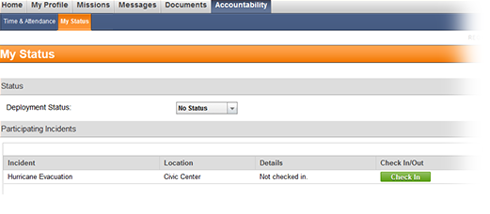
Under this tab, you can manage your personal deployment status as well as check in and out of incidents.

Change Your Deployment Status*
* Note: You may not be able to perform this action depending on your system configuration.
To change your deployment status
1. Go to Accountability: My Status. The following page opens.
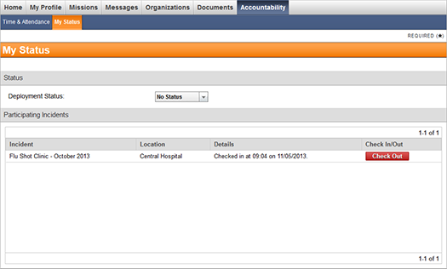
2. Select the desired status in the Deployment Status drop-down list. Your deployment status applies to all incidents you are participating in.
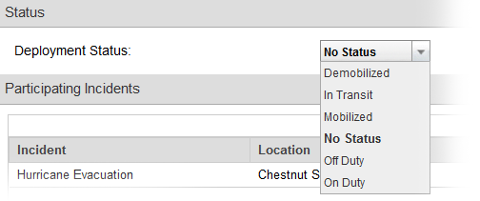

Check In and Out
Important: An administrator may have disabled self-check in/out for certain locations. If so, an on-scene officer will check you in and out.
To check in to an incident
1. Go to Accountability: My Status. The following page opens.
2. Click Check In next to the corresponding incident under the Participating Incidents section.
To check out of an incident
1. Go to Accountability: My Status.
2. Click Check Out next to the corresponding incident under the Participating Incidents section.

Glossary
A
Accepted: A status of an organization membership request showing that the administrator has accepted the request and the responder is now a member of the organization.
Account: Collection of information that identifies a CORES user.
Account Status: The state of a user account. It could be active, inactive, closed, or archived.
Account Type: The type of account. Differentiated between responder accounts and all types of administrator accounts.
Active Account: Responders with active accounts can be contacted about emergency deployments and receive notifications related to potential emergency activations and deployments.
Archived: Mission status showing that the mission has been archived. Archiving is an alternative to deleting a mission from the system; however, an archived mission can be reverted to its previous status. Missions that have been archived do not appear in reports or contribute towards responder hours.
Archived Account: Archiving an account is an alternative to deleting it. Once archived, the account no longer appears in the system.
B
Badge: An identification card issued to a responder by the administrator. Badges provide evidence that the responder is registered in the system and verify his or her identity, occupation or title, and unit affiliation.
C
Call Center Operator: Can view all missions and send notifications. Not all systems contain this system role.
Closed: Mission status showing that all deployment groups in the mission have been closed.
Closed Account: An account that has been terminated and can no longer be used. Responders with closed accounts cannot log into their account or receive notifications.
Complete: Mission status showing that all deployments in the mission have ended.
Credential Verification: Various ways of connecting to licensure databases to verify a responder’s credentials.
Credentials Verification Organization (CVO): A CVO certification is available to organizations that conduct credentials verification, report the credentialing information to clients, and have systems in place to protect the confidentiality and integrity of the information.
D
Declined: See Rejected.
Default Organization: The default organization contains users matching one or more of the following criteria: users have not specified an organization during registration; users have not been accepted to any organizations; users have withdrawn their organization memberships; users have been removed from organizations by the administrator.
Deployed: Mission status showing that at least one deployment group in the mission has been deployed.
Deployment: The distribution of several groups of responders in response to an emergency.
Deployment Preferences: Where responders are willing to travel, how long they are willing to be deployed, and any other emergency response commitments.
Deployment Status: Responder status that helps track on-scene time and attendance and provides additional details about the location and availability of a responder.
Document Library: An optional module available for purchase that allows users to share and exchange documents.
E
Emergency Credential Level (ECL): Part of the ESAR-VHP guidelines, a way to determine how much credential information has been accepted and verified about a particular individual.
ESAR-VHP: ESAR-VHP (Emergency System for Advance Registration of Volunteer Health Professionals) System is an electronic database of health care personnel who volunteer to provide aid in an emergency. An ESAR-VHP System must (1) register health volunteers, (2) apply emergency credentialing standards to registered volunteers, and (3) allow for the verification of the identity, credentials, and qualifications of registered volunteers in an emergency.
ESF #8: The ESF (Emergency Support Function) is a mechanism that consolidates multiple agencies that perform similar or like functions into a single, cohesive unit to allow for the better management of emergency response functions. ESF #8, Public Health and Medical Services includes behavioral health needs of incident victims and response workers, additional medical response assistance for medical needs populations, and veterinary and/or animal health issues.
F
Filters: Filters show information within a table that meets certain criteria. Use the drop down menu at the upper right above the table to filter display results.
G
Group: A collection of users in the system that allows administrators to simultaneously perform an action on multiple users. For example, users can be grouped based on their residence location to receive alerts relevant to that particular location.
I
Inactive Account: Responders with inactive accounts do not appear in search results and cannot be contacted about potential emergency activations and deployments; however, they may receive non-emergency notifications related to the status of their account.
Incident Job: A specific job function that an assigned responder should perform during an incident. Jobs are specific to the Accountability module and should not be confused with occupations.
Internal Message: A message sent and received through the CORES’s internal messaging system.
J
Job: See Incident Job.
L
Local Administrator: can perform many functions in the system, including some access to the Administration and Configuration modules. These administrators are limited by organization access level permissions in the Messages, Organizations, Document Library, Accountability, sand Mission Manager modules, where available.
M
Medical Reserve Corps (MRC): The MRC was founded in 2002. It is a partner program with Citizen Corps, a national network of responders dedicated to ensuring hometown security. Citizen Corps, along with AmeriCorps, Senior Corps, and the Peace Corps are part of the President’s USA Freedom Corps, which promotes volunteerism and service nationwide. MRC organizations are community-based and function as a way to locally organize and utilize volunteers who want to donate their time and expertise to prepare for and respond to emergencies and promote healthy living throughout the year. MRC volunteers supplement existing emergency and public health resources.
Mission: A potential deployment situation.
Mission Manager: A module within CORES to help administrators locate, request, and deploy responders during an emergency situation or pre-planned incident.
N
New: Mission status showing that the mission does not have any deployment groups.
O
Occupation Category: Indicates whether the occupation is medical or non-medical.
Occupation Credential Information: Occupation categories, types, and current status. Options are: Licensed and Active, Licensed and Active Part-Time, Licensed and Inactive for Less than 5 Years, Licensed and Inactive for More than 5 Years, Non-Licensed and Active, Non-Licensed and Retired, Non-Licensed and Student. Up to three (3) licenses, memberships, work experiences, and other categories are accepted.
Occupation Type: The profession of a responder. All occupations are classified as medical and non-medical.
On-scene Officer: A designated user with the rights to manage responders at specific locations within an incident. This user role exists only in the Accountability module and does not give the user administrator rights.
Organization: Organizations represent institutions and associations that exist in real world, such as government agencies, health care, non-profit or legal organizations.
P
Password Requirements: Responder passwords must be at least six (6) characters long, include at least one numeral, one letter, and contain no spaces. Administrator passwords must be at least eight (8) characters long, include one numeral, one letter and contain no spaces. Passwords are case sensitive.
Pending: A status of an organization membership request showing that the administrator has not yet taken any action on this request.
Profile: All information collected during registration, including identity, organization membership, deployment preferences, contact, skills and certifications, training, occupations, and medical history. Profile also includes a special link, Settings, to edit specific account information.
Q
Quick Search: Located in the top right corner of the page and provides instant search results when searching for a responder or group by name.
R
Regional Administrator: Can perform many functions in the system, including some access to the Administration and Configuration modules. These administrators are limited by organization access level permissions in the Messages, Organizations, Document Library, Accountability, and Mission Manager modules, where available.
Rejected: A status of an organization membership request showing that the administrator has rejected the request and the user cannot be an organization member.
Requesting Authority: An outside party that requests assistance during an emergency or an event.
Required Fields: Required fields are indicated by asterisks (*). An error will occur if information is not entered in a required field.
Researching: A default status of an organization membership request showing that the administrator is gathering additional information to determine whether the responder's organization affiliation is authentic.
Responder: Any person who could potentially respond during a disaster situation. Responders do not have the ability to manage or view others in the system, and they can only compose messages to administrators and respond to notifications they receive. They do not have access to the Administration or Configuration modules. Their access can be limited or expanded by their assigned organization access level permissions and other granular permissions in the Organizations, Document Library, and Accountability modules, where available.
Roles: See specific roles: Local Administrator, Regional Administrator, State Administrator, Responder, and Call Center Operator.
Roster: A list of all responders who can potentially be involved in incident response efforts.
S
Schedule Manager: A module that allows administrators to manage personnel during an activation by allowing rostered responders to be placed in shifts over the course of a deployment.
Secondary Navigation Bar: The second row of tabs on the navigation toolbar. These tabs give you access to specific functions of a module.
Service Location: The location where responders will be providing service during an emergency or event.
Staffing: Mission status to indicate that responders can be assigned to the available deployment groups.
State Administrator: Can perform all functions available on the system and have full access to the Administration and Configuration modules. They have access to all organizations and can modify details, members, access levels, unaffiliated responders, and network information for any created organization, regardless of their access level permissions. They can also manage users within the system.
U
Unaffiliated Users: Users who do not have valid organization membership.
Unknown: Responder status showing that the responder has not indicated his or her availability.
V
Voice Notification: A method to notify responders using a text-to-speech engine to call and inform responders of an emergency.

Index

A
access levels 63, 73
add members to 65
create 62
details 64
B
background check 10
badge
scan 110
C
certifications 9
container
recipient 36
recipient statistics 36
D
delivery method 37
demobilized 111
deployment status 111, 113
change 113
document
check in 85
check out 85
download 89
search 102
document library 75
documents
manage 76
share 76
download 89
document 89
file 89
drafts 34
E
export
document library 30
sent message 30
statistics 30
F
file
check in 85
check out 85
delete 93
download 89
logs 94
move 95
permissions 89, 97
restore 93
shortcut 96, 99
upload 80
versions 86
watch 97, 101
file details 82
edit 82
view 82
folder
create 77
delete 93
details 79
logs 94
move 95
new 77
permissions 89, 97
watch 97, 101
folder details
edit 79
view 79
front page 1
H
home 1
home page 1
I
identity 4
in transit 111
inbox 16
M
medical history 10
member
organization 58
message
check inbox 16
compose 18
delivery 37
drafts 34
export 30
review 22
sent 20, 22
share sent 22
statistics 22
trash 35
voice 45
mobilized 111
my documents 100
my organizations 53
view 53
O
off duty 111
on duty 111
organization 55
access levels 73
administrators 68, 71
details 56
join 69, 71
members 72
network 67, 74
overview 70
reports 69
withdraw 55
P
permissions 97
cascade 89
manage 89
profile summary 3
R
recipients 26
add 19
container 36
view 26
reports
organization 69
responders
check in/check out 105
review
message 22
S
schedule 15
sent
message 30
PHIN communications 20
share
sent message 22
skills 9
statistics
export 30
recipient 36
sent message 22
status
account 11
deployment 111
organization membership 58
summary 3
T
text-to-speech 45
time & attendance 104
log 106
training 8
trash 35
delete 20
U
upload
file 80
V
version
manage 86

